SECTION 27 41 16
INTEGRATED AUDIO-VIDEO SYSTEMS AND EQUIPMENT

GUIDE SPECIFICATION

Specifier: The Specifier/Design Professional is responsible for the accuracy of all project specifications, including system application and coordination with related sections. This guide specification is provided as a convenience and requires editing to match actual project requirements. CRESTRON ELECTRONICS, INC. SHALL NOT BE LIABLE FOR ANY DAMAGES ARISING OUT OF THE USE OF ANY OF ITS GUIDE SPECIFICATIONS. For Crestron design assistance and design review please contact Sales Support Services Department at 800.237.2041 or techsales@crestron.com.

Specifier: Please see PART 4 for a listing of products specified in this Guide Specification.

Table of Contents
1 GENERAL 5
2 PRODUCTS 5
2.1 4K60 4:4:4 Transmitter for USB C® DisplayPort™, USB 2.0, and Ethernet Signal Extension over CATx Cable 5
2.1.1 Basis of Design 5
2.1.2 Device Definition 5
2.1.3 Device Architecture 5
2.1.4 Functions 6
2.1.5 Connectors 7
2.1.6 Controls and Indicators 8
2.1.7 Power 9
2.1.8 Compliance 9
2.2 4K60 4:4:4 Transmitter for USB C® DisplayPort™, USB 2.0, and Ethernet Signal Extension over CATx Cable, Wall Plate 9
2.2.1 Basis of Design 9
2.2.2 Device Definition 9
2.2.3 Device Architecture 10
2.2.4 Functions 10
2.2.5 Connectors 11
2.2.6 Controls and Indicators 12
2.2.7 Power 13
2.2.8 Compliance 13
2.3 4K60 4:4:4 Transmitter and 2x1 Auto-Switcher for HDMI® and USB 2.0 Signal Extension over CATx Cable 13
2.3.1 Basis of Design 14
2.3.2 Device Definition 14
2.3.3 Device Architecture 14
2.3.4 Functions 15
2.3.5 Connectors 16
2.3.6 Controls and Indicators 18
2.3.7 Power 19
2.3.8 Compliance 19
2.4 4K60 4:4:4 Transmitter and 2x1 Auto-Switcher for HDMI® and USB 2.0 Signal Extension over CATx Cable with Charger 19
2.4.1 Basis of Design 20
2.4.2 Device Definition 20
2.4.3 Device Architecture 20
2.4.4 Functions 21
2.4.5 Connectors 22
2.4.6 Controls and Indicators 24
2.4.7 Power 25
2.4.8 Compliance 25
2.5 4K60 4:4:4 Receiver for HDMI®, USB 2.0, and Ethernet Signal Extension over CATx Cable 26
2.5.1 Basis of Design 26
2.5.2 Device Definition 26
2.5.3 Device Architecture 26
2.5.4 Functions 27
2.5.5 Connectors 28
2.5.6 Controls and Indicators 29
2.5.7 Power 30
2.5.8 Compliance 30
2.6 4K60 4:4:4 Receiver for HDMI® and USB 2.0 Signal Extension over CATx Cable, Wall Plate 30
2.6.1 Basis of Design 30
2.6.2 Device Definition 30
2.6.3 Device Architecture 31
2.6.4 Functions 31
2.6.5 Connectors 32
2.6.6 Controls and Indicators 33
2.6.7 Power 34
2.6.8 Compliance 34
2.7 4K60 4:4:4 Receiver and 2x2 Auto-Switcher for HDMI® and USB 2.0 Signal Extension over CATx Cable 34
2.7.1 Basis of Design 34
2.7.2 Device Definition 34
2.7.3 Device Architecture 35
2.7.4 Functions 35
2.7.5 Connectors 37
2.7.6 Controls and Indicators 38
2.7.7 Power 40
2.7.8 Compliance 40
3 EXECUTION 40
4 APPENDICES 41
4.1 SPECIFIED PRODUCTS 41
4.1.1 Crestron HD-TXU-4KZ-111-E 41
4.1.2 Crestron HD-TXU-4KZ-111-2G 41
4.1.3 Crestron HD-TXU-4KZ-211 41
4.1.4 Crestron HD-TXU-4KZ-211-CHGR 41
4.1.5 Crestron HD-RXU-4KZ-101-E 41
4.1.6 Crestron HD-RXU-4KZ-101-2G 41
4.1.7 Crestron HD-RXU-4KZ-202 41
4.2 Input / Output Connection Diagrams 41
4.2.1 HD-TXU-4KZ-111-E 41
4.2.2 HD-TXU-4KZ-111-2G 41
4.2.3 HD-TXU-4KZ-211 42
4.2.4 HD-TXU-4KZ-211-CHGR 42
4.2.5 HD-RXU-4KZ-101-E 42
4.2.6 HD-RXU-4KZ-101-2G 43
4.2.7 HD-RXU-4KZ-202 43

GENERAL
NOT USED in this Guide Specification. Specifier shall Specify PART 1 administrative and procedural requirements as needed.

PRODUCTS

4K60 4:4:4 Transmitter for USB C® DisplayPort™, USB 2.0, and Ethernet Signal Extension over CATx Cable

Specifier Note:
The HD-TXU-4KZ-111-E is a DM Lite® 4K60 4:4:4 transmitter designed to interoperate with a DM Lite HD-RXU-4KZ Series receiver. A USB-C® input with DisplayPort™ Alt Mode capability enables the transmission of a DisplayPort AV signal. The USB-C input also enables the transmission of USB 2.0 data signals. In addition, a LAN port enables Ethernet pass-through capability. A CAT5e or higher twisted pair cable is used to connect the HD-TXU-4KZ-111-E to the DM Lite receiver.

Basis of Design

Crestron HD-TXU-4KZ-111-E

Device Definition

Device with the following characteristics:

Point to point transmission of USB-C DisplayPort, USB 2.0, and Ethernet signals over CAT5e and higher twisted pair cable

Designed for interoperability with receivers from same manufacturer

4K60 4:4:4 and HDR support

HDR10, HDR10+, and Dolby Vision® video format support

HDCP 2.3 compliant

CEC pass-through capability

Ethernet pass-through support

Surface-mountable form factor

Device Architecture

Construction

Chassis: Metal, black finish, vented top and sides

Mounting: Freestanding, surface mountable or attachment to a single rack rail

Two (2) mounting brackets included

Dimensions

Height: 1.20 in. (30 mm)

Width: 4.19 in. (106 mm)

Depth: 7.94 in. (202 mm)

Weight: 1.2 lb. (0.55 kg)

Environmental Operating Conditions

Temperature: 32° to 104° F (0° to 40° C)

Humidity: 20% to 90% RH (non-condensing)

Functions

Video

Input signal Type

DisplayPort™ over USB-C® (DisplayPort Alt Mode)

HDR10, HDR10+, Dolby Vision®, Deep Color, 4K60 4:4:4 support

Output Signal Type

Proprietary signal format by same manufacturer

HDR10, HDR10+, Dolby Vision®, Deep Color, and 4K60 4:4:4 support

Specifier Note: 4K60 4:4:4 performance and HDR support require the use of USB 3.2 Gen 1 (5 Gbps) cables with support for DisplayPort Alt Mode (DisplayPort 1.4 video, 4K60 4:4:4, 2 lanes).

Copy Protection: HDCP 2.3

Specifier Note: Please refer to the device’s spec sheet for a table of common resolutions that are supported. The maximum supported resolution is 4K60 with 4:4:4 color sampling. Custom resolutions are supported at pixel clock rates up to 600 MHz. This device does not support interlaced video.

Audio

Input Signal Type: DisplayPort over USB-C (DisplayPort Alt Mode)

Output Signal Type: Proprietary signal format by same manufacturer

Digital Formats: Dolby Digital®, Dolby Digital EX, Dolby Digital Plus, Dolby® TrueHD, Dolby Atmos®, DTS®, DTS ES, DTS 96/24, DTS HD® High Res, DTS-HD Master Audio, DTS: X®, LPCM up to 8 channels

Communications

USB-C: HDCP 2.3, EDID, CEC pass-through, USB 2.0 up to 300 Mbps

USB

USB signal extension via USB 2.0 host ports

USB host for cable caddy by same manufacturer via SERVICE port

Proprietary signal format: HDCP 2.3, EDID pass-through, USB 2.0 up to 300 Mbps

Ethernet: 100/1000 Mbps pass-through

Connectors

USB INPUT

(1) USB Type-C® connector, female

Digital video/audio input using DisplayPort Alt Mode

USB 2.0 data support

Proprietary signal out

(1) 8-pin RJ45 yellow connector, female, shielded

Output port for connection to receiver by same manufacturer

LAN

(1) 8-pin RJ45 connector, female

100BASE-TX/1000BASE-T Ethernet port

Passes Ethernet signal over the proprietary signal connection to receiver by same manufacturer

24 V 1.4 A

(1) 2.1 x 5.5 mm DC power connector

24 VDC power input

Specifier Note: Power packs supporting above power delivery specifications are not to be connected to both transmitter and receiver devices simultaneously. In instances where a surface-mounted device is connected to a wall plate device, the power pack included with the surface-mounted device is used to power both endpoints.

HOST

(2) USB Type-A connectors, female

USB 2.0 host ports

USB signal extender ports for connection to USB mice, keyboards, or other USB 2.0 peripheral devices

Available Power: 500 mA @ 5 VDC per port

SERVICE

(1) USB 2.0 Type-A connector, female

Used for firmware loading, configuration management, or as a USB host port for cable caddy by same manufacturer

Can also provide up to 5 VDC 500 mA power to a USB powered device

Ground: (1) Chassis ground lug

Controls and Indicators

PWR

(1) LED, indicates that power is being applied to the device

Amber indicates that the device is booting

Green indicates that the device is operational

INPUT

(1) Green LED, indicates that the device is receiving a DisplayPort over USB-C (DisplayPort Alt Mode) input signal

Proprietary signal out

(2) LEDs on RJ45 connector

Green indicates that a signal link is established

Flashing amber indicates non-HDCP video

Solid amber indicates HDCP video

LAN

(2) LEDs on RJ45 connector

Green indicates that a 100 Mbps link is established

Solid amber indicates that a 1000 Mbps link is established

Flashing amber indicates 1000 Mbps Ethernet activity

Power

Power Pack

Input: 100-240 VAC

Output: 24 VDC 2.5 A

Compliance

Regulatory Model: M202047005

Intertek® Listed for US and Canada, CE, IC, FCC Part 15 Class B digital device

4K60 4:4:4 Transmitter for USB C® DisplayPort™, USB 2.0, and Ethernet Signal Extension over CATx Cable, Wall Plate

Specifier Note:
The HD-TXU-4KZ-111-2G is a DM Lite® 4K60 4:4:4 transmitter designed to interoperate with a DM Lite HD-RXU-4KZ Series receiver. A USB-C® input with DisplayPort™ Alt Mode capability enables the transmission of a DisplayPort AV signal. The USB-C input also enables the transmission of USB 2.0 data signals. A CAT5e or higher twisted pair cable is used to connect the HD-TXU-4KZ-111-2G to the DM Lite receiver.

Basis of Design

Crestron HD-TXU-4KZ-111-2G

Device Definition

Device with the following characteristics:

Point to point transmission of USB-C DisplayPort and USB 2.0 signals over CAT5e and higher twisted pair cable

Designed for interoperability with receivers from same manufacturer

4K60 4:4:4 and HDR support

HDR10, HDR10+, and Dolby Vision® video format support

HDCP 2.3 compliant

CEC pass-through capability

Two gang wall plate form factor

Device Architecture

Construction

Composition: Metal housing and bracket with black and white polycarbonate front label overlay

Mounting: Mounts into a 2-gang (or larger) 2-inch (51 mm) deep U.S. electrical box or plaster ring

Faceplate: Requires a decorator style faceplate

Dimensions

Height: 4.12 in. (105 mm)

Width: 3.57 in. (91 mm)

Depth: 1.70 in. (43 mm)

Weight: 7.25 oz (206 g)

Environmental Operating Conditions

Temperature: 32° to 104° F (0° to 40° C)

Humidity: 20% to 90% RH (non-condensing)

Functions

Video

Input signal Type

DisplayPort™ over USB-C® (DisplayPort Alt Mode)

HDR10, HDR10+, Dolby Vision®, Deep Color, 4K60 4:4:4 support

Output Signal Type

Proprietary signal format by same manufacturer

HDR10, HDR10+, Dolby Vision®, Deep Color, and 4K60 4:4:4 support

Specifier Note: 4K60 4:4:4 performance and HDR support require the use of USB 3.2 Gen 1 (5 Gbps) cables with support for DisplayPort Alt Mode (DisplayPort 1.4 video, 4K60 4:4:4, 2 lanes).

Copy Protection: HDCP 2.3

Specifier Note: Please refer to the device’s spec sheet for a table of common resolutions that are supported. The maximum supported resolution is 4K60 with 4:4:4 color sampling. Custom resolutions are supported at pixel clock rates up to 600 MHz. This device does not support interlaced video.

Audio

Input Signal Type: DisplayPort over USB-C (DisplayPort Alt Mode)

Output Signal Type: Proprietary signal format by same manufacturer

Digital Formats: Dolby Digital®, Dolby Digital EX, Dolby Digital Plus, Dolby® TrueHD, Dolby Atmos®, DTS®, DTS ES, DTS 96/24, DTS HD® High Res, DTS-HD Master Audio, DTS: X®, LPCM up to 8 channels

Communications

USB-C: HDCP 2.3, EDID, CEC pass-through, USB 2.0 up to 300 Mbps

USB

USB signal extension via USB 2.0 host ports

Proprietary signal format: HDCP 2.3, EDID pass-through, USB 2.0 up to 300 Mbps

Connectors

USB IN

(1) USB Type-C® connector, female

Digital video/audio input using DisplayPort Alt Mode

USB 2.0 data support

Proprietary signal out

(1) 8-pin RJ45 yellow connector, female, shielded

Output port for connection to receiver by same manufacturer

LAN

(1) 8-pin RJ45 connector, female

100BASE-TX/1000BASE-T Ethernet port

Passes Ethernet signal over the proprietary signal connection to receiver by same manufacturer

24 V 0.5 A

(1) 2-in 3.5 mm detachable terminal block

24 VDC power input

Power pack required only if device is used with wall plate receiver by same manufacturer

Specifier Note: Power packs supporting above power delivery specifications are not to be connected to both transmitter and receiver devices simultaneously. In instances where a surface-mounted device is connected to a wall plate device, the power pack included with the surface-mounted device is used to power both endpoints.

HOST

(2) USB Type-A connectors, female

USB 2.0 host ports

USB signal extender ports for connection to USB mice, keyboards, or other USB 2.0 peripheral devices

Available Power: 500 mA @ 5 VDC per port

Ground: (1) Chassis ground lug

Controls and Indicators

PWR

(1) LED, indicates that power is being applied to the device

Amber indicates that the device is booting

Green indicates that the device is operational

USB IN

(1) Green LED, indicates that the device is receiving a DisplayPort over USB-C (DisplayPort Alt Mode) input signal

LINK

(1) Green LED, indicates that proprietary signal link is established

RESET: (1) Push button, restores factory default settings

Proprietary signal out

(2) LEDs on RJ45 connector

Green indicates that a signal link is established

Flashing amber indicates non-HDCP video

Solid amber indicates HDCP video

Power

Power Pack

Input: 100-240 VAC

Output: 24 VDC 0.75 A

Compliance

Regulatory Model: M202047004

Intertek® Listed for US and Canada, CE, IC, FCC Part 15 Class B digital device

4K60 4:4:4 Transmitter and 2x1 Auto-Switcher for HDMI® and USB 2.0 Signal Extension over CATx Cable

Specifier Note:
The HD-TXU-4KZ-211 is a DM Lite® 4K60 4:4:4 transmitter designed to interoperate with a DM Lite® HD-RXU-4KZ Series receiver. The HDMI® and associated USB-C® input of the HD-TXU-4KZ-211 enable the transmission of HDMI AV and USB 2.0 data signals. The USB-C input with DisplayPort™ Alt Mode capability enables the transmission of DisplayPort AV and USB 2.0 data signals. A CAT5e or higher twisted pair cable is used to connect the HD-TXU-4KZ-211 to the DM Lite receiver.

Basis of Design

Crestron HD-TXU-4KZ-211

Device Definition

Device with the following characteristics:

Point to point extension of USB-C DisplayPort, HDMI, and USB 2.0 signals over CAT5e and higher twisted pair cable

Two (2) inputs with automatic switching

Designed for interoperability with receivers from same manufacturer

4K60 4:4:4 and HDR support

HDR10, HDR10+, and Dolby Vision® video format support

HDCP 2.3 compliant

Support for proprietary remote configuration and monitoring software by same manufacturer

Interoperability with control system by same manufacturer

Support for browser-based setup and configuration with control system via proprietary software suite

Integrated web server for device configuration and management

EDID management

Automatic display control via CEC

Device Architecture

Construction

Chassis: Metal, black finish, vented top, front, rear, and sides

Mounting: Freestanding, surface mountable, or attachment to a single rack rail

Two (2) mounting brackets included

Dimensions

Height: 1.20 in. (30 mm)

Width: 8.52 in. (216 mm)

Depth: 6.48 in. (165 mm)

Weight: 1.93 lb. (0.88 kg)

Environmental Operating Conditions

Temperature: 32° to 104° F (0° to 40° C)

Humidity: 20% to 90% RH (non-condensing)

Functions

Video

Input signal Types

HDMI®

DVI and Dual-Mode DisplayPort™ interface compatible

USB-C DisplayPort Alt Mode

HDR10, HDR10+, Dolby Vision®, Deep Color, 4K60 4:4:4 support

Output Signal Type

Proprietary signal format by same manufacturer

HDR10, HDR10+, Dolby Vision®, Deep Color, and 4K60 4:4:4 support

Specifier Note: 4K60 4:4:4 performance and HDR support require the use of cables and couplers with a minimum TMDS bandwidth of 18 Gbps. If 4K60 4:2:0 or 4K30 4:4:4 performance is acceptable, cables and couplers with a minimum bandwidth of 10.2 Gbps may be used. Bandwidth loss is cumulative; therefore, performance may be reduced when inserting multiple cables and couplers inline.

Copy Protection: HDCP 2.3

Specifier Note: Please refer to the device’s spec sheet for a table of common resolutions that are supported. The maximum supported resolution is 4K60 with 4:4:4 color sampling. Custom resolutions are supported at pixel clock rates up to 600 MHz. The USB-C DisplayPort input does not support interlaced video.

Audio

Input Signal Types: HDMI, USB-C DisplayPort Alt mode

Output Signal Type: Proprietary signal format by same manufacturer

Digital Formats: Dolby Digital®, Dolby Digital EX, Dolby Digital Plus, Dolby® TrueHD, Dolby Atmos®, DTS®, DTS ES, DTS 96/24, DTS HD® High Res, DTS-HD Master Audio, DTS: X®, LPCM up to 8 channels

Communications

HDMI: HDCP 2.3, EDID, CEC

USB-C: HDCP 2.3, EDID, CEC, USB 2.0 up to 300 Mbps

USB

USB signal extension via USB 2.0 host and device ports

Proprietary signal format: HDCP 2.3, EDID, USB 2.0 up to 300 Mbps

Ethernet

100/1000 Mbps, auto-switching, auto negotiating, auto-discovery, full/half duplex, DHCP, web browser setup and control, integration with control system by same manufacturer, IEEE 802.1X, Secure CIP Authentication, SSH/SSL, TLS

Connectors

SERVICE

(1) USB 2.0 Type-A connector, female

Used for firmware loading and configuration management

Can also provide up to 5 V 500 mA power to a USB powered device

24 V 1.9 A

(1) 2.1 x 5.5 mm DC power connector

24 VDC power input

Specifier Note: Power packs supporting above power delivery specifications are not to be connected to both transmitter and receiver devices simultaneously. In instances where a surface-mounted device is connected to a wall plate device, the power pack included with the surface-mounted device is used to power both endpoints.

USB, INPUT 1

(1) USB Type-C® connector, female

Digital video/audio input using DisplayPort Alt Mode

USB 2.0 data support

HDMI, INPUT 2

(1) HDMI Type A connector, female

HDMI digital video/audio input

DVI and Dual-Mode DisplayPort interface compatible

Specifier Note: The HDMI output requires an appropriate adapter or interface cable to accommodate a Dual-Mode DisplayPort or DVI signal.

DEVICE, INPUT 2

(1) USB Type-C® connector, female

USB 2.0 device port associated with HDMI input for AV sources that require USB 2.0 support

USB signal extender port for connection to a computer or other USB 2.0 host

HOST

(2) USB Type-A connectors, female

USB 2.0 host ports

USB signal extender ports for connection to USB mice, keyboards, or other USB 2.0 peripheral devices

Available Power: 500 mA @ 5 VDC per port

Proprietary signal out

(1) 8-pin RJ45 yellow connector, female, shielded

Output port for connection to receiver by same manufacturer

LAN

(1) 8-pin RJ45 connector, female

100BASE-TX/1000BASE-T Ethernet port for device configuration and management

Ground: (1) Chassis ground lug

Controls and Indicators

PWR

(1) LED, indicates that power is being applied to the device

Amber indicates that the device is booting

Green indicates that the device is operational

AUTO

(1) Push button for enabling or disabling automatic switching of inputs

(1) LED, green indicates that automatic switching of inputs is enabled

SETUP

(1) Push button for Ethernet setup

(1) LED, red indicates that the SETUP push button is pressed

INPUT 1

(1) Push button for manual selection of USB-C DisplayPort input

(1) LED

Green indicates that the USB-C DisplayPort input is routed to an output

Amber indicates that a source is detected but is not routed to an output

INPUT 2

(1) Push button for manual selection of HDMI input

(1) LED

Green indicates that the HDMI input is routed to an output

Amber indicates that a source is detected but is not routed to an output

Proprietary signal out

(2) LEDs on RJ45 connector

Green indicates that a signal link is established

Flashing amber indicates non-HDCP video

Solid amber indicates HDCP video

LAN

(2) LEDs on RJ45 connector

Green indicates that a 100 Mbps link is established

Solid amber indicates that a 1000 Mbps link is established

Flashing amber indicates 1000 Mbps Ethernet activity

Power

Power Pack

Input: 100-240 VAC

Output: 24 VDC 2.5 A

Compliance

Regulatory Model: M202047007

Intertek® Listed for US and Canada, CE, IC, FCC Part 15 Class B digital device

4K60 4:4:4 Transmitter and 2x1 Auto-Switcher for HDMI® and USB 2.0 Signal Extension over CATx Cable with Charger

Specifier Note:
The HD-TXU-4KZ-211-CHGR is a DM Lite® 4K60 4:4:4 transmitter designed to interoperate with a DM Lite® HD-RXU-4KZ Series receiver. The HDMI® and associated USB-C® input of the HD-TXU-4KZ-211-CHGR enable the transmission of HDMI AV and USB 2.0 data signals. The USB-C input with DisplayPort™ Alt Mode capability enables the transmission of DisplayPort AV and USB 2.0 data signals. A CAT5e or higher twisted pair cable is used to connect the HD-TXU-4KZ-211-CHGR to the DM Lite receiver. When the HD-TXU-4KZ-211-CHGR is powered by the included power pack, the USB-C DisplayPort input can charge the connected AV source (for example, a laptop) with up to 60 W of power. If the HD-TXU-4KZ-211-CHGR is powered by a remote DM Lite receiver, no charging capability is provided by the USB-C input.

Basis of Design

Crestron HD-TXU-4KZ-211-CHGR

Device Definition

Device with the following characteristics:

Point to point extension of USB-C DisplayPort, HDMI, and USB 2.0 signals over CAT5e and higher twisted pair cable

USB-C DisplayPort charging up to 60 W

Two (2) inputs with automatic switching

Designed for interoperability with receivers from same manufacturer

4K60 4:4:4 and HDR support

HDR10, HDR10+, and Dolby Vision® video format support

HDCP 2.3 compliant

Support for proprietary remote configuration and monitoring software by same manufacturer

Interoperability with control system by same manufacturer

Support for browser-based setup and configuration with control system via proprietary software suite

Integrated web server for device configuration and management

EDID management

Automatic display control via CEC

Device Architecture

Construction

Chassis: Metal, black finish, vented top, front, rear, and sides

Mounting: Freestanding, surface mountable, or attachment to a single rack rail

Two (2) mounting brackets included

Dimensions

Height: 1.20 in. (30 mm)

Width: 8.52 in. (216 mm)

Depth: 6.48 in. (165 mm)

Weight: 1.96 lb. (0.89 kg)

Environmental Operating Conditions

Temperature: 32° to 104° F (0° to 40° C)

Humidity: 20% to 90% RH (non-condensing)

Functions

Video

Input signal Types

HDMI®

DVI and Dual-Mode DisplayPort™ interface compatible

USB-C DisplayPort Alt Mode

HDR10, HDR10+, Dolby Vision®, Deep Color, 4K60 4:4:4 support

Output Signal Type

Proprietary signal format by same manufacturer

HDR10, HDR10+, Dolby Vision®, Deep Color, and 4K60 4:4:4 support

Specifier Note: 4K60 4:4:4 performance and HDR support require the use of cables and couplers with a minimum TMDS bandwidth of 18 Gbps. If 4K60 4:2:0 or 4K30 4:4:4 performance is acceptable, cables and couplers with a minimum bandwidth of 10.2 Gbps may be used. Bandwidth loss is cumulative; therefore, performance may be reduced when inserting multiple cables and couplers inline.

Copy Protection: HDCP 2.3

Specifier Note: Please refer to the device’s spec sheet for a table of common resolutions that are supported. The maximum supported resolution is 4K60 with 4:4:4 color sampling. Custom resolutions are supported at pixel clock rates up to 600 MHz. The USB-C DisplayPort input does not support interlaced video.

Audio

Input Signal Types: HDMI, USB-C DisplayPort Alt mode

Output Signal Type: Proprietary signal format by same manufacturer

Digital Formats: Dolby Digital®, Dolby Digital EX, Dolby Digital Plus, Dolby® TrueHD, Dolby Atmos®, DTS®, DTS ES, DTS 96/24, DTS HD® High Res, DTS-HD Master Audio, DTS: X®, LPCM up to 8 channels

Communications

HDMI: HDCP 2.3, EDID, CEC

USB-C: HDCP 2.3, EDID, CEC, USB 2.0 up to 300 Mbps

USB

USB signal extension via USB 2.0 host and device ports

Proprietary signal format: HDCP 2.3, EDID, USB 2.0 up to 300 Mbps

Ethernet

100/1000 Mbps, auto-switching, auto negotiating, auto-discovery, full/half duplex, DHCP, web browser setup and control, integration with control system by same manufacturer, IEEE 802.1X, Secure CIP Authentication, SSH/SSL, TLS

Connectors

SERVICE

(1) USB 2.0 Type-A connector, female

Used for firmware loading and configuration management

Can also provide up to 5 V 500 mA power to a USB powered device

24 V 4.5 A

(1) 2.1 x 5.5 mm DC power connector

24 VDC power input

Specifier Note: Power packs supporting above power delivery specifications are not to be connected to both transmitter and receiver devices simultaneously. In instances where a surface-mounted device is connected to a wall plate device, the power pack included with the surface-mounted device is used to power both endpoints.

60 W USB, INPUT 1

(1) USB Type-C® connector, female

Digital video/audio input using DisplayPort Alt Mode

USB 2.0 data support

Charging of connected AV source up to 60 W available

Specifier Note: For the USB-C DisplayPort input to charge the connected AV source, the HD-TXU-4KZ-211-CHGR must be powered by the included power pack. If the HD-TXU-4KZ-211-CHGR is powered by a remote DM Lite receiver, no charging capability is provided by USB-C input.

HDMI, INPUT 2

(1) HDMI Type A connector, female

HDMI digital video/audio input

DVI and Dual-Mode DisplayPort interface compatible

Specifier Note: The HDMI output requires an appropriate adapter or interface cable to accommodate a Dual-Mode DisplayPort or DVI signal.

DEVICE, INPUT 2

(1) USB Type-C® connector, female

USB 2.0 device port associated with HDMI input for AV sources that require USB 2.0 support

USB signal extender port for connection to a computer or other USB 2.0 host

HOST

(2) USB Type-A connectors, female

USB 2.0 host ports

USB signal extender ports for connection to USB mice, keyboards, or other USB 2.0 peripheral devices

Available Power: 500 mA @ 5 VDC per port

Proprietary signal out

(1) 8-pin RJ45 yellow connector, female, shielded

Output port for connection to receiver by same manufacturer

LAN

(1) 8-pin RJ45 connector, female

100BASE-TX/1000BASE-T Ethernet port for device configuration and management

Ground: (1) Chassis ground lug

Controls and Indicators

PWR

(1) LED, indicates that power is being applied to the device

Amber indicates that the device is booting

Green indicates that the device is operational

AUTO

(1) Push button for enabling or disabling automatic switching of inputs

(1) LED, green indicates that automatic switching of inputs is enabled

SETUP

(1) Push button for Ethernet setup

(1) LED, red indicates that the SETUP push button is pressed

INPUT 1

(1) Push button for manual selection of USB-C DisplayPort input

(1) LED

Green indicates that the USB-C DisplayPort input is routed to an output

Amber indicates that a source is detected but is not routed to an output

INPUT 2

(1) Push button for manual selection of HDMI input

(1) LED

Green indicates that the HDMI input is routed to an output

Amber indicates that a source is detected but is not routed to an output

Proprietary signal out

(2) LEDs on RJ45 connector

Green indicates that a signal link is established

Flashing amber indicates non-HDCP video

Solid amber indicates HDCP video

LAN

(2) LEDs on RJ45 connector

Green indicates that a 100 Mbps link is established

Solid amber indicates that a 1000 Mbps link is established

Flashing amber indicates 1000 Mbps Ethernet activity

Power

Power Pack

Input: 100-240 VAC

Output: 24 VDC 7.5 A

Compliance

Regulatory Model: M202047007

Intertek® Listed for US and Canada, CE, IC, FCC Part 15 Class B digital device

4K60 4:4:4 Receiver for HDMI®, USB 2.0, and Ethernet Signal Extension over CATx Cable

Specifier Note:
The HD-RXU-4KZ-101-E is a DM Lite® 4K60 4:4:4 receiver designed to interoperate with a DM Lite HD-TXU-4KZ Series transmitter for the transmission of HDMI® and USB 2.0 signals. In addition, a LAN port enables Ethernet pass-through capability. A CAT5e or higher twisted pair cable is used to connect the HD-RXU-4KZ-101-E to the DM Lite transmitter.

Basis of Design

Crestron HD-RXU-4KZ-101-E

Device Definition

Device with the following characteristics:

Point to point extension of HDMI, USB 2.0, and Ethernet signals over CAT5e and higher twisted pair cable

Designed for interoperability with transmitters from same manufacturer

4K60 4:4:4 and HDR support

HDR10, HDR10+, and Dolby Vision® video format support

HDCP 2.3 compliant

CEC pass-through capability

Ethernet pass-through support

Device Architecture

Construction

Chassis: Metal, black finish, vented top and sides

Mounting: Freestanding, surface mountable, or attachment to a single rack rail

Two (2) mounting brackets included

Dimensions

Height: 1.20 in. (30 mm)

Width: 4.19 in. (106 mm)

Depth: 7.94 in. (202 mm)

Weight: 1.19 lb. (0.54 kg)

Environmental Operating Conditions

Temperature: 32° to 104° F (0° to 40° C)

Humidity: 20% to 90% RH (non-condensing)

Functions

Video

Input signal Type

Proprietary signal format by same manufacturer

HDR10, HDR10+, Dolby Vision®, Deep Color, 4K60 4:4:4 support

Output Signal Type

HDMI®

HDR10, HDR10+, Dolby Vision®, Deep Color, and 4K60 4:4:4 support

Specifier Note: 4K60 4:4:4 performance and HDR support require the use of cables and couplers with a minimum TMDS bandwidth of 18 Gbps. If 4K60 4:2:0 or 4K30 4:4:4 performance is acceptable, cables and couplers with a minimum bandwidth of 10.2 Gbps may be used. Bandwidth loss is cumulative; therefore, performance may be reduced when inserting multiple cables and couplers inline.

Copy Protection: HDCP 2.3

Specifier Note: Please refer to the device’s spec sheet for a table of common resolutions that are supported. The maximum supported resolution is 4K60 with 4:4:4 color sampling. Custom resolutions are supported at pixel clock rates up to 600 MHz.

Audio

Input Signal Type: Proprietary signal format by same manufacturer

Output Signal Type: HDMI

Digital Formats: Dolby Digital®, Dolby Digital EX, Dolby Digital Plus, Dolby® TrueHD, Dolby Atmos®, DTS®, DTS ES, DTS 96/24, DTS HD® High Res, DTS-HD Master Audio, DTS: X®, LPCM up to 8 channels

Communications

HDMI: HDCP 2.3, EDID, CEC pass-through

Proprietary signal format: HDCP 2.3, EDID pass-through, USB 2.0 up to 300 Mbps

USB

USB signal extension via USB 2.0 host ports

USB host for cable caddy by same manufacturer via SERVICE Port

Ethernet: 100/1000 Mbps pass-through

Connectors

HDMI OUTPUT

(1) HDMI Type A connector, female

HDMI digital video/audio output

DVI compatible

Specifier Note: The HDMI output requires an appropriate adapter or interface cable to accommodate a DVI signal.

Proprietary signal in

(1) 8-pin RJ45 yellow connector, female, shielded

Input port for connection to transmitter by same manufacturer

LAN

(1) 8-pin RJ45 connector, female

100BASE-TX/1000BASE-T Ethernet port

Receives Ethernet signal over the proprietary signal connection from transmitter by same manufacturer

24 V 1.4 A

(1) 2.1 x 5.5 mm DC power connector

24 VDC power input

Specifier Note: Power packs supporting above power delivery specifications are not to be connected to both transmitter and receiver devices simultaneously. In instances where a surface-mounted device is connected to a wall plate device, the power pack included with the surface-mounted device is used to power both endpoints.

HOST

(2) USB Type-A connectors, female

USB 2.0 host ports

USB signal extender ports for connection to USB mice, keyboards, or other USB 2.0 peripheral devices

Available Power: 500 mA @ 5 VDC per port

SERVICE

(1) USB 2.0 Type-A connector, female

Used for firmware loading, configuration management, or as a USB host port for cable caddy by same manufacturer

Ground: (1) Chassis ground lug

Controls and Indicators

PWR

(1) LED, indicates that power is being applied to the device

Amber indicates that the device is booting

Green indicates that the device is operational

OUTPUT

(1) Green LED, indicates that the device is transmitting an HDMI signal

Proprietary signal in

(2) LEDs on RJ45 connector

Green indicates that a signal link is established

Flashing amber indicates non-HDCP video

Solid amber indicates HDCP video

LAN

(2) LEDs on RJ45 connector

Green indicates that a 100 Mbps link is established

Solid amber indicates that a 1000 Mbps link is established

Flashing amber indicates 1000 Mbps Ethernet activity

Power

Power Pack

Input: 100-240 VAC

Output: 24 VDC 1.3 A

Compliance

Regulatory Model: M202047006

Intertek® Listed for US and Canada, CE, IC, FCC Part 15 Class B digital device

4K60 4:4:4 Receiver for HDMI® and USB 2.0 Signal Extension over CATx Cable, Wall Plate

Specifier Note:
The HD-RXU-4KZ-101-2G is a DM Lite® 4K60 4:4:4 wall plate receiver designed to interoperate with a DM Lite HD-TXU-4KZ Series transmitter for the transmission of HDMI® and USB 2.0 signals. A CAT5e or higher twisted pair cable is used to connect the HD-RXU-4KZ-101-2G to the DM Lite transmitter.

Basis of Design

Crestron HD-RXU-4KZ-101-2G

Device Definition

Device with the following characteristics:

Point to point extension of HDMI and USB 2.0 signals over CAT5e and higher twisted pair cable

Designed for interoperability with transmitters from same manufacturer

4K60 4:4:4 and HDR support

HDR10, HDR10+, and Dolby Vision® video format support

HDCP 2.3 compliant

CEC pass-through capability

Two gang wall plate form factor

Device Architecture

Construction

Composition: Metal housing and bracket with black polycarbonate front label overlay

Mounting: Mounts in a 2-gang (or larger) 2-inch (51 mm) deep U.S. electrical box or plaster ring

Faceplate: Requires a decorator style faceplate

Dimensions

Height: 4.12 in. (105 mm)

Width: 3.57 in. (91 mm)

Depth: 1.70 in. (43 mm)

Weight: 6.87 oz (195 g)

Environmental Operating Conditions

Temperature: 32° to 104° F (0° to 40° C)

Humidity: 20% to 90% RH (non-condensing)

Functions

Video

Input signal Type

Proprietary signal format by same manufacturer

HDR10, HDR10+, Dolby Vision®, Deep Color, 4K60 4:4:4 support

Output Signal Type

HDMI®

HDR10, HDR10+, Dolby Vision®, Deep Color, and 4K60 4:4:4 support

DVI compatible

Specifier Note: 4K60 4:4:4 performance and HDR support require the use of cables and couplers with a minimum TMDS bandwidth of 18 Gbps. If 4K60 4:2:0 or 4K30 4:4:4 performance is acceptable, cables and couplers with a minimum bandwidth of 10.2 Gbps may be used. Bandwidth loss is cumulative; therefore, performance may be reduced when inserting multiple cables and couplers inline.

Specifier Note: The HDMI output requires an appropriate adapter or interface cable to accommodate a DVI signal.

Copy Protection: HDCP 2.3

Specifier Note: Please refer to the device’s spec sheet for a table of common resolutions that are supported. The maximum supported resolution is 4K60 with 4:4:4 color sampling. Custom resolutions are supported at pixel clock rates up to 600 MHz.

Audio

Input Signal Type: Proprietary signal format by same manufacturer

Output Signal Type: HDMI

Digital Formats: Dolby Digital®, Dolby Digital EX, Dolby Digital Plus, Dolby® TrueHD, Dolby Atmos®, DTS®, DTS ES, DTS 96/24, DTS HD® High Res, DTS-HD Master Audio, DTS: X®, LPCM up to 8 channels

Communications

HDMI: HDCP 2.3, EDID, CEC pass-through

Proprietary signal format: HDCP 2.3, EDID pass-through, USB 2.0 up to 300 Mbps

USB

USB signal extension via USB 2.0 host ports

Connectors

HDMI OUT

(1) HDMI Type A connector, female

HDMI digital video/audio output

DVI compatible

HOST

(2) USB Type-A connectors, female

USB 2.0 host ports

USB signal extender ports for connection to USB mice, keyboards, or other USB 2.0 peripheral devices

Available Power: 500 mA @ 5 VDC per port

Proprietary signal in

(1) 8-pin RJ45 yellow connector, female, shielded

Input port for connection to transmitter by same manufacturer

24 V 0.5 A

(1) 2-pin 3.5 mm detachable terminal block

24 VDC power input

Specifier Note: Power packs supporting above power delivery specifications are not to be connected to both transmitter and receiver devices simultaneously. In instances where a surface-mounted device is connected to a wall plate device, the power pack included with the surface-mounted device is used to power both endpoints.

Ground: (1) Chassis ground lug

Controls and Indicators

PWR

(1) LED, indicates that power is being applied to the device

Amber indicates that the device is booting

Green indicates that the device is operational

HDMI OUT

(1) Green LED, indicates that the device is transmitting an HDMI signal

LINK

(1) Green LED, indicates that a proprietary signal link is established

RESET: (1) Push Button, restores factory default settings

Proprietary signal in

(2) LEDs on RJ45 connector

Green indicates that a signal link is established

Flashing amber indicates non-HDCP video

Solid amber indicates HDCP video

Power

Power Pack

Input: 100-240 VAC

Output: 24 VDC 0.75 A

Compliance

Regulatory Model: M202047004

Intertek® Listed for US and Canada, CE, IC, FCC Part 15 Class B digital device

4K60 4:4:4 Receiver and 2x2 Auto-Switcher for HDMI® and USB 2.0 Signal Extension over CATx Cable

Specifier Note:
The HD-RXU-4KZ-202 is a DM Lite® 4K60 4:4:4 receiver designed to interoperate with a DM Lite HD-TXU-4KZ Series transmitter for the transmission of HDMI® and USB 2.0 signals. A CAT5e or higher twisted pair cable is used to connect the HD-RXU-4KZ-202 to the DM Lite transmitter.

Basis of Design

Crestron HD-RXU-4KZ-202

Device Definition

Device with the following characteristics:

Point to point extension of HDMI and USB 2.0 signals over CAT5e and higher twisted pair cable

Two (2) inputs with automatic switching

Designed for interoperability with transmitters from same manufacturer

4K60 4:4:4 and HDR support

HDR10, HDR10+, and Dolby Vision® video format support

HDCP 2.3 compliant

Support for proprietary remote configuration and monitoring software by same manufacturer

Interoperability with control system by same manufacturer

Support for browser-based setup and configuration with control system via proprietary software suite

Integrated web server for device configuration and management

EDID management

Automatic display control via CEC

Device Architecture

Construction

Chassis: Metal, black finish, vented top and sides

Mounting: Freestanding, surface mountable, or attachment to a single rack rail

Two (2) mounting brackets included

Dimensions

Height: 1.20 in. (30 mm)

Width: 8.52 in. (216 mm)

Depth: 6.48 in. (165 mm)

Weight: 1.95 lb. (0.88 kg)

Environmental Operating Conditions

Temperature: 32° to 104° F (0° to 40° C)

Humidity: 20% to 90% RH (non-condensing)

Functions

Video

Input signal Types

HDMI®

DVI and Dual-Mode DisplayPort™ interface compatible

Proprietary signal format by same manufacturer

HDR10, HDR10+, Dolby Vision®, Deep Color, 4K60 4:4:4 support

Output Signal Type

HDMI®

HDR10, HDR10+, Dolby Vision®, Deep Color, and 4K60 4:4:4 support

Specifier Note: 4K60 4:4:4 performance and HDR support require the use of cables and couplers with a minimum TMDS bandwidth of 18 Gbps. If 4K60 4:2:0 or 4K30 4:4:4 performance is acceptable, cables and couplers with a minimum bandwidth of 10.2 Gbps may be used. Bandwidth loss is cumulative; therefore, performance may be reduced when inserting multiple cables and couplers inline.

Copy Protection: HDCP 2.3

Specifier Note: Please refer to the device’s spec sheet for a table of common resolutions that are supported. The maximum supported resolution is 4K60 with 4:4:4 color sampling. Custom resolutions are supported at pixel clock rates up to 600 MHz.

Audio

Input Signal Types: HDMI, Proprietary signal format by same manufacturer

Output Signal Type: HDMI

Digital Formats: Dolby Digital®, Dolby Digital EX, Dolby Digital Plus, Dolby® TrueHD, Dolby Atmos®, DTS®, DTS ES, DTS 96/24, DTS HD® High Res, DTS-HD Master Audio, DTS: X®, LPCM up to 8 channels

Communications

HDMI: HDCP 2.3, EDID, CEC

Proprietary signal format: HDCP 2.3, EDID, USB 2.0 up to 300 Mbps

USB

USB signal extension via USB 2.0 host and device ports

Ethernet

100/1000 Mbps, auto-switching, auto negotiating, auto-discovery, full/half duplex, DHCP, web browser setup and control, integration with control system by same manufacturer, IEEE 802.1X, Secure CIP Authentication, SSH/SSL, TLS

Connectors

SERVICE

(1) USB 2.0 Type-A connector, female

Used for firmware loading and configuration management

Can also provide up to 5 V 500 mA power to a USB powered device

24 V 1.9 A

(1) 2.1 x 5.5 mm DC power connector

24 VDC power input

Specifier Note: Power packs supporting above power delivery specifications are not to be connected to both transmitter and receiver devices simultaneously. In instances where a surface-mounted device is connected to a wall plate device, the power pack included with the surface-mounted device is used to power both endpoints.

HDMI OUTPUT 1-2

(2) HDMI Type A connectors, female

HDMI digital video/audio output

DVI compatible

Specifier Note: The HDMI output requires an appropriate adapter or interface cable to accommodate a DVI signal.

HDMI INPUT 1

(1) HDMI Type A connector, female

HDMI digital video/audio input

DVI and Dual-Mode DisplayPort interface compatible

Specifier Note: The HDMI input requires an appropriate adapter or interface cable to accommodate a Dual-Mode DisplayPort or DVI signal.

DEVICE INPUT 1

(1) USB Type-C® connector, female

USB 2.0 device port associated with HDMI input for AV sources that require USB 2.0 support

USB signal extender port for connection to a computer or other USB 2.0 host

HOST

(2) USB Type-A connectors, female

USB 2.0 host ports

USB signal extender ports for connection to USB mice, keyboards, or other USB 2.0 peripheral devices

Available Power: 500 mA @ 5 VDC per port

Proprietary signal in

(1) 8-pin RJ45 yellow connector, female, shielded

Input port for connection to transmitter by same manufacturer

LAN

(1) 8-pin RJ45 connector, female

100BASE-TX/1000BASE-T Ethernet port for device configuration and management

Ground: (1) Chassis ground lug

Controls and Indicators

PWR

(1) LED, indicates that power is being applied to the device

Amber indicates that the device is booting

Green indicates that the device is operational

AUTO

(1) Push button for enabling or disabling automatic switching of inputs

(1) LED, green indicates that automatic switching of inputs is enabled

SETUP

(1) Push button for Ethernet setup

(1) LED, red indicates that the SETUP push button is pressed

INPUT 1

(1) Push button for manual selection of HDMI input

(1) LED

Green indicates that the HDMI input is routed to an output

Amber indicates that a source is detected but is not routed to an output

INPUT 2

(1) Push button for manual selection of proprietary signal input

(1) LED

Green indicates that the proprietary signal input is routed to an output

Amber indicates that a source is detected but is not routed to an output

OUTPUT 1

(1) Push button for manual selection of HDMI output 1

(1) LED

Green indicates that a display or other destination device is detected and HDMI output 1 is transmitting video

Amber indicates that a display or other destination device is detected but no video is routed to the output

OUTPUT 2

(1) Push button for manual selection of HDMI output 2

(1) LED

Green indicates that a display or other destination device is detected and HDMI output 2 is transmitting video

Amber indicates that a display or other destination device is detected but no video is routed to the output

Proprietary signal in

(2) LEDs on RJ45 connector

Green indicates that a signal link is established

Flashing amber indicates non-HDCP video

Solid amber indicates HDCP video

LAN

(2) LEDs on RJ45 connector

Green indicates that a 100 Mbps link is established

Solid amber indicates that a 1000 Mbps link is established

Flashing amber indicates 1000 Mbps Ethernet activity

Power

Power Pack

Input: 100-240 VAC

Output: 24 VDC 2.5 A

Compliance

Regulatory Model: M202047008

Intertek® Listed for US and Canada, CE, IC, FCC Part 15 Class B digital device

EXECUTION
NOT USED in this Guide Specification. Specifier shall Specify PART 3 On-Site work as needed.

APPENDICES

SPECIFIED PRODUCTS
Specifier Note: This Article includes Crestron products specified in this Guide Specification document. This Article is for reference only and should not be required in actual project manual unless included in an overall system equipment list.

Crestron HD-TXU-4KZ-111-E

Crestron HD-TXU-4KZ-111-2G

Crestron HD-TXU-4KZ-211

Crestron HD-TXU-4KZ-211-CHGR

Crestron HD-RXU-4KZ-101-E

Crestron HD-RXU-4KZ-101-2G

Crestron HD-RXU-4KZ-202

Input / Output Connection Diagrams

HD-TXU-4KZ-111-E
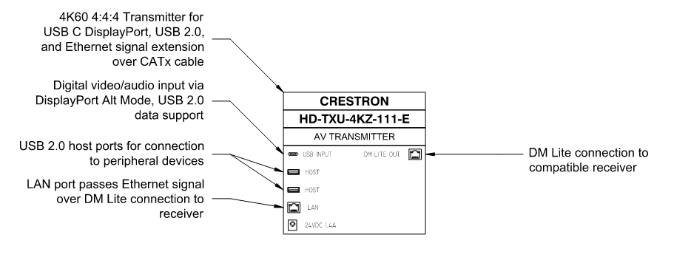

HD-TXU-4KZ-111-2G
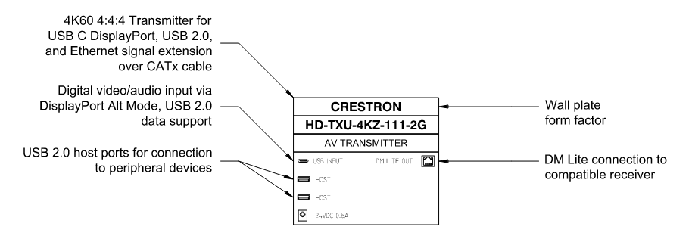

HD-TXU-4KZ-211
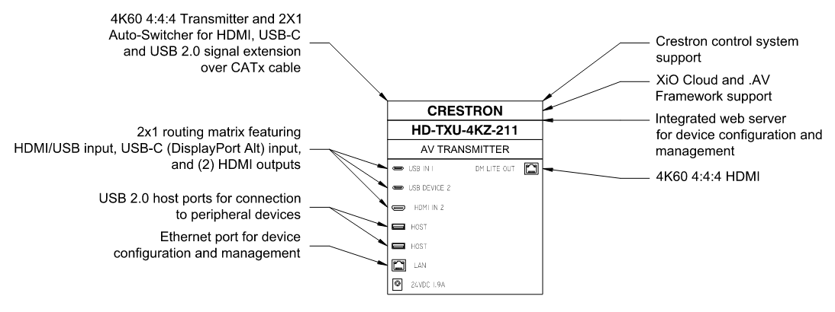

HD-TXU-4KZ-211-CHGR
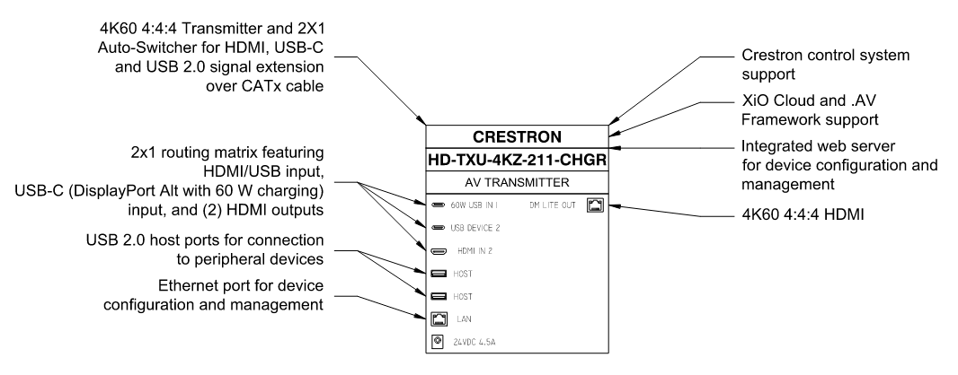

HD-RXU-4KZ-101-E
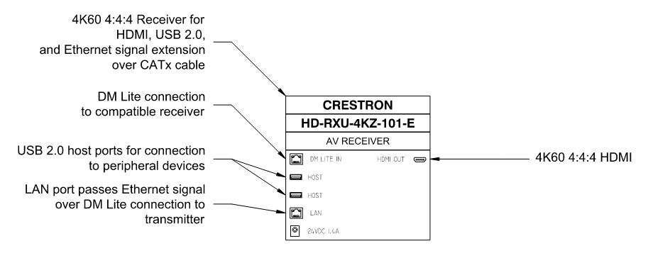

HD-RXU-4KZ-101-2G
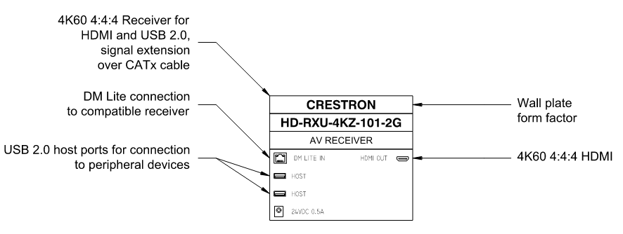

HD-RXU-4KZ-202
