SECTION 27 41 16
INTEGRATED AUDIO-VIDEO SYSTEMS AND EQUIPMENT

GUIDE SPECIFICATION

Specifier: The Specifier/Design Professional is responsible for the accuracy of all project specifications, including system application and coordination with related sections. This guide specification is provided as a convenience and requires editing to match actual project requirements. CRESTRON ELECTRONICS, INC. SHALL NOT BE LIABLE FOR ANY DAMAGES ARISING OUT OF THE USE OF ANY OF ITS GUIDE SPECIFICATIONS. For Crestron design assistance and design review please contact Sales Support Services Department at 800.237.2041 or techsales@crestron.com.

Specifier: Please see PART 4 for a listing of products specified in this Guide Specification.

Table of Contents
1 GENERAL 3
2 PRODUCTS 3
2.1 Unified Communications Audio Wireless Transceiver and Auto Mixer 3
2.1.1 Basis of Design 3
2.1.2 Device Definition 3
2.1.3 Device Architecture 3
2.1.4 Functions 4
2.1.5 Connectors 4
2.1.6 Controls and Indicators 4
2.1.7 Compliance 5
2.2 Unified Communications Wireless Speaker and Microphone 5
2.2.1 Basis of Design 5
2.2.2 Device Definition 5
2.2.3 Device Architecture 6
2.2.4 Functions 6
2.2.5 Connectors 7
2.2.6 Controls and Indicators 7
2.2.7 Compliance 8
3 EXECUTION 8
4 APPENDICES 8
4.1 SPECIFIED PRODUCTS 8
4.1.1 Crestron UC-AUDIO-HUB 8
4.1.2 Crestron UC-AUDIO-POD 8
4.2 Input / Output Connection Diagrams 8
4.2.1 UC-AUDIO-HUB 8
4.2.2 UC-AUDIO-POD 9

GENERAL
NOT USED in this Guide Specification. Specifier shall Specify PART 1 administrative and procedural requirements as needed.

PRODUCTS

Unified Communications Audio Wireless Transceiver and Auto Mixer

Specifier Note:
The Crestron® Flex UC-AUDIO-HUB is a wireless transceiver and auto mixer that connects with up to four paired Crestron Flex UC-AUDIO-POD units simultaneously through Digital Enhanced Cordless Telecommunications (DECT) technology. The UC-AUDIO-HUB receives audio from each connected UC-AUDIO-POD microphone and transfers the auto-mixed audio to a UC Engine via USB. The Flex Hub also distributes audio from the UC Engine via USB to all connected UC-AUDIO-POD units simultaneously.

Basis of Design

Crestron UC-AUDIO-HUB

Device Definition

Unified Communications Audio Wireless Transceiver with the following capabilities:

Support of multiple proprietary wireless speaker and microphone device connections via Digital Enhanced Cordless Telecommunications (DECT) technology

Automatic mixing of incoming audio from proprietary wireless speaker and microphone devices sent to soft codec by same manufacturer

Reception and distribution of audio from soft codec by same manufacturer to all DECT connected proprietary wireless and speaker microphone devices

Support for proprietary remote configuration and monitoring software by same manufacturer

Device Architecture

Construction

Enclosure: Lightly textured black finish, plastic housing

Mounting: Freestanding, stackable, surface mount and wall / ceiling mount option with included black plastic bracket

Dimensions

Height: 1.35 in. (34 mm), 1.77 in. (45 mm) with bracket

Width: 5.04 in. (128 mm), 5.36 in. (137 mm) with bracket

Depth: 5.20 in. (133 mm)

Weight: 8.9 oz (253 g) without bracket

Environmental Operating Conditions

Temperature: 41° to 104° F (5° to 40° C)

Humidity: 10% to 95% RH (noncondensing)

Heat Dissipation: 12.3 BTU/hr

Functions

Wireless Communication

Frequency

DECT ULE Frequency Bands

US: 1920 - 1930 MHz 5 channels

Europe: 1880 - 1900 MHz 10 channels

Range up to 50 ft. (approx. 15 m) indoor

Connectors

USB-C: USB-C (PC) connection for audio and HID data

24 VDC, 0.75 A: 24 VDC 0.75 A via external 100-240 VAC power pack, included

RJ45: 1000 Mbps Ethernet

Controls and Indicators

Buttons

Pair: Tactile push button

Reset: Recessed push button

Indicators

Power: Green LED indicates device is powered on

Sync: Five SYNC LEDs indicate pairing and connection to each proprietary wireless speaker and microphone device

Compliance

Regulatory Model: M202109001

IC, CE, FCC Part 15 Class B digital device, Intertek® Listed for US & Canada

Unified Communications Wireless Speaker and Microphone

Specifier Note:
The Crestron® Flex UC-AUDIO-POD is a wireless tabletop conferencing device with speaker and microphone that is ideal for small to large rooms. The Flex Pod wirelessly connects and transfers audio to and from a paired Crestron Flex UC-AUDIO-HUB. The connected Flex Hub receives and sends audio to a UC Engine through a USB connection. Up to four Flex Pods can connect with a Flex Hub simultaneously providing omnidirectional sound in large or medium conference rooms and multi-purpose meeting spaces.

Basis of Design

Crestron UC-AUDIO-POD

Device Definition

Unified Communications wireless speaker and microphone with the following capabilities:

Digital Enhanced Cordless Telecommunications (DECT) connection to wireless transceiver and auto mixer by same manufacturer

360° microphone pickup

Acoustic echo cancellation

Automatic gain compensation

Noise reduction

In-call volume and mic mute controls

Speaker volume indicator and LED indicator ring

Optional tabletop mounting accessory and Kensington® lock support

Flexibility in room placement according to site conditions

Support for proprietary remote configuration and monitoring software by same manufacturer

Device Architecture

Construction

Enclosure

Lightly textured black finish

Plastic housing

Perforated stainless steel grilles

Die-cast aluminum bottom cover

Mounting: Tabletop mounting only

Dimensions

Height: 3.0 in. (76 mm)

Width: 4.40 in. (112 mm)

Depth: 4.25 in. (108 mm)

Weight: 1.6 lb. (726 g)

Environmental Operating Conditions

Temperature: 41° to 104° F (5° to 40° C)

Humidity: 10% to 95% RH (noncondensing)

Heat Dissipation: 12 BTU/hr

Functions

Wireless Communication

Frequency

DECT ULE Frequency Bands

US: 1920 - 1930 MHz 5 channels

Europe: 1880 - 1900 MHz 10 channels

Range up to 50 ft. (approx. 15 m) indoor

Audio

DSP

Acoustic echo cancellation

Automatic gain control

Dynamic noise suppression

Speaker volume control

Full-duplex IEEE 1329 Type 1 compliant

Speaker

Range: One full range 2 in. speaker

Frequency Response: 100 Hz to 7 kHz

Output Level: 74 dB SPL at 1 m

Microphone

Microphone: 360° quad mic array

Pickup Range: 10 ft. (approx. 3 m)

Connectors

USB-C: 5 VDC, 3 A via external 100-240 VAC power pack (included with device)

Security Port: Kensington Security Slot™ port

Controls and Indicators

Buttons

Speaker Volume Up / Down: Capacitive, backlit

Mic Mute: Capacitive, backlit

Pair: Push button

Reset: Recessed push button

Indicators

Mic Unmute: Green LED indicates microphone is unmuted

Mic Mute: Red LED indicates microphone is muted

Volume Level: White LED indicates the speaker volume

Compliance

Regulatory Model: M202109002

IC, CE, FCC Part 15 Class B digital device, Intertek® Listed for US & Canada

Full-duplex IEEE 1329 Type 1 Compliant

EXECUTION
NOT USED in this Guide Specification. Specifier shall Specify PART 3 On-Site work as needed.

APPENDICES

SPECIFIED PRODUCTS
Specifier Note: This Article includes Crestron products specified in this Guide Specification document. This Article is for reference only and should not be required in actual project manual unless included in an overall system equipment list.

Crestron UC-AUDIO-HUB

Crestron UC-AUDIO-POD

Input / Output Connection Diagrams

UC-AUDIO-HUB
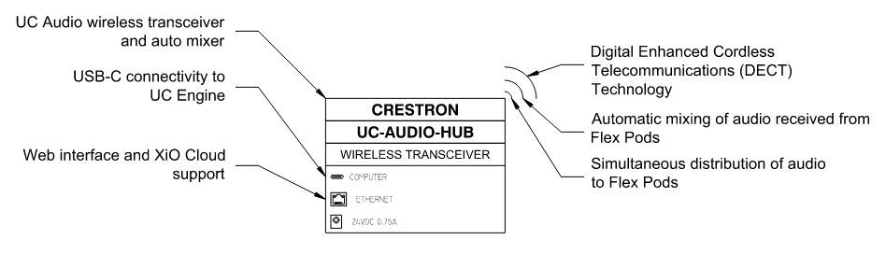

UC-AUDIO-POD
