SECTION 27 41 16
INTEGRATED AUDIO-VIDEO SYSTEMS AND EQUIPMENT

GUIDE SPECIFICATION

Specifier: The Specifier/Design Professional is responsible for the accuracy of all project specifications, including system application and coordination with related sections. This guide specification is provided as a convenience and requires editing to match actual project requirements. CRESTRON ELECTRONICS, INC. SHALL NOT BE LIABLE FOR ANY DAMAGES ARISING OUT OF THE USE OF ANY OF ITS GUIDE SPECIFICATIONS. For Crestron design assistance and design review please contact Sales Support Services Department at 800.237.2041 or techsales@crestron.com.

Specifier: Please see PART 4 for a listing of products specified in this Guide Specification.

Table of Contents
1 GENERAL 5
2 PRODUCTS 5
2.1 In-Wall Universal Phase Dimmer with Wireless Communication, 120 VAC 5
2.1.1 Basis of Design 5
2.1.2 Device Definition 5
2.1.3 Device Architecture 6
2.1.4 Functions 7
2.1.5 Connectors 7
2.1.6 Controls and Indicators 8
2.1.7 Power 9
2.1.8 Compliance 9
2.2 In-Wall Forward Phase Dimmer with Wireless Communication, 120 VAC 9
2.2.1 Basis of Design 9
2.2.2 Device Definition 10
2.2.3 Device Architecture 10
2.2.4 Functions 11
2.2.5 Connectors 12
2.2.6 Controls and Indicators 13
2.2.7 Power 14
2.2.8 Compliance 14
2.3 In-Wall 0-10 V Dimmer with Wireless Communication, 120 VAC 14
2.3.1 Basis of Design 14
2.3.2 Device Definition 14
2.3.3 Device Architecture 15
2.3.4 Functions 16
2.3.5 Connectors 16
2.3.6 Controls and Indicators 17
2.3.7 Power 18
2.3.8 Compliance 18
2.4 In-Wall Switch with Wireless Communication, 120 VAC 18
2.4.1 Basis of Design 18
2.4.2 Device Definition 19
2.4.3 Device Architecture 19
2.4.4 Functions 20
2.4.5 Connectors 21
2.4.6 Controls and Indicators 21
2.4.7 Power 22
2.4.8 Compliance 22
2.5 In-Wall Keypad with Wireless Communication, 120 VAC 22
2.5.1 Basis of Design 23
2.5.2 Device Definition 23
2.5.3 Device Architecture 23
2.5.4 Functions 24
2.5.5 Connectors 25
2.5.6 Controls and Indicators 25
2.5.7 Power 26
2.5.8 Compliance 27
2.6 In-Wall Multiway Remote 27
2.6.1 Basis of Design 27
2.6.2 Device Definition 27
2.6.3 Device Architecture 27
2.6.4 Functions 28
2.6.5 Connectors 28
2.6.6 Controls and Indicators 29
2.6.7 Power 29
2.6.8 Compliance 29
2.7 In-Wall Keypad with Proprietary Wired Communication 29
2.7.1 Basis of Design 30
2.7.2 Device Definition 30
2.7.3 Device Architecture 30
2.7.4 Functions 31
2.7.5 Connectors 31
2.7.6 Controls and Indicators 32
2.7.7 Power 33
2.7.8 Compliance 33
3 EXECUTION 33
4 APPENDICES 33
4.1 SPECIFIED PRODUCTS 33
4.1.1 Crestron HZ2-DIMUEX 33
4.1.2 Crestron HZ2-DIMEX 33
4.1.3 Crestron HZ2-DIMLVEX 33
4.1.4 Crestron HZ2-SWEX 33
4.1.5 Crestron HZ2-KPEX 33
4.1.6 Crestron HZ2-AUX 33
4.1.7 Crestron HZ2-KPCN 33
4.2 Input / Output Connection Diagrams 33
4.2.1 HZ2-DIMUEX 33
4.2.2 HZ2-DIMEX 34
4.2.3 HZ2-DIMLVEX 34
4.2.4 HZ2-SWEX 35
4.2.5 HZ2-KPEX 35
4.2.6 HZ2-AUX 36
4.2.7 HZ2-KPCN 36

GENERAL
NOT USED in this Guide Specification. Specifier shall Specify PART 1 administrative and procedural requirements as needed.

PRODUCTS

In-Wall Universal Phase Dimmer with Wireless Communication, 120 VAC

Specifier Note:
The HZ2-DIMUEX is a Horizon® 2 in-wall universal phase dimmer that provides infiNET EX® wireless network control of LED, incandescent, magnetic low voltage, and electronic low voltage loads. It has the ability to adjust minimum and maximum light levels and to set the dimming curve to be linear, logarithmic, or use a custom curve. Its design matches the entire line of Horizon dimmers, switches, and keypads, making it a great addition to new or retrofit installations.

Basis of Design

Crestron HZ2-DIMUEX

Device Definition

In-wall universal phase dimmer with the following capabilities:

Forward and reverse phase dimming

Over current protection

Auto load detection to select the appropriate dimming method for attached load

LED, incandescent, magnetic low voltage, and electronic low voltage support

Support for dimming curve adjustment to be linear, logarithmic, or custom

Support for defined minimum and maximum light levels

Support for proprietary wireless communications system by same manufacturer

Support for proprietary home / MDU automation operating system by same manufacturer

Fully programmable when connected to control system by same manufacturer

Integrated keypad functionality to trigger commands in control system by same manufacturer

Local button functionality for load control without programming

Support for custom button layout and engraving, field replaceable as needed

Blank button assemblies available for engraving by third party

Custom color RGB LED button backlight support

Backlight intensity to adjust automatically according to amount of ambient light in room via ambient light sensor

Installation in standard US electrical wall box

Side-by-side installation with up to four (4) devices from same product line in US multi gang electrical box

Multiway lighting control support with devices from same manufacturer

Availability in the following colors: white, almond, black

Device Architecture

Construction

Mounting

Mounts in a 1- to 4-gang U.S. electrical box (not included)

Metal mounting ring included

3.5 in. (26 mm) electrical box depth recommended

Derating required in multi gang applications

Faceplate

Requires faceplate with mounting bracket by same manufacturer

Metal mounting bracket to provide precise alignment during device installation and faceplate assembly

Multi gang installations require a 2-, 3-, or 4-gang faceplate with mounting bracket by same manufacturer

Dimensions

Height: 4.38 in. (112 mm)

Width: 1.80 in. (46 mm)

Depth: 1.75 in. (45 mm) overall, extends 0.44 in. (12 mm) from wall surface when installed

Weight: 6.7 oz. (190 g)

Environmental Operating Conditions

Temperature: 32° to 86° F (0° to 30° C)

Humidity: 10% to 90% RH (noncondensing)

Functions

Load Control

Load Type: LED, Incandescent, Magnetic Low Voltage, Electronic Low Voltage

Load Rating: 600 W/VA maximum; no minimum load

Preset Fade Time: 1 second (default) when operated without a control system by same manufacturer; fade time is adjustable when controlled by a control system by same manufacturer

Wireless

RF Transceiver

Proprietary 2-way RF, 2.4 GHz ISM Channels 11-26 (2400 to 2483.5 MHz)

Default channel 15

IEEE 802.15.4 compliant

Range (typical)

150 ft. (46 m) indoor

250 ft. (76 m) outdoor to nearest mesh network device; subject to site-specific conditions and individual device capabilities

Communication with control system requires gateway device, all by same manufacturer

Support for up to 100 devices by same manufacturer on proprietary wireless network

Connectors

Load

(1) Screw clamp terminal, consists of (2) wire inserts and (1) red screw head

Load output: Accepts (1) 14-12 AWG wire per insert, do not insert wires behind screw head

Line

(1) Screw clamp terminal, consists of (2) wire inserts and (1) black screw head

Line power input: Accepts (1) 14-12 AWG wire per insert, do not insert sires behind screw head

Neutral

(1) Screw clamp terminal, consists of (2) wire inserts and (1) silver screw head

Neutral input: Accepts (1) 14-12 AWG wire per insert, do not insert wires behind screw head

Remote

(1) Screw clamp terminal, consists of (2) wire inserts and (1) blue screw head

Remote input from auxiliary devices by same manufacturer, accepts (1) 14-12 AWG wire per insert, do not insert wires behind screw head

Ground

(1) 12 AWG flying lead, Class 1, green with yellow stripe, wire nut included

Controls and Indicators

Airgap: (1) Switch at the bottom of the device; controls power to the device and connected loads

(1) Switch at the bottom of the device

Controls power to the device and connected loads

Pushbutton

(9) Pushbuttons located under the button assembly

Pushbuttons are actuated by the button assembly that is installed

Button Assembly

(1) Button assembly included

Compatible with button configurations as specified by manufacturer

Setup

(1) Pushbutton

Front of the faceplate must be removed to access the pushbutton

Can be used to set the local LED backlight color theme or calibrate the ambient light sensor

LED Feedback

(5) RGB LED backlights

Supports one local color theme for all LEDs

Supports one alternate color theme for each backlit position

White LED backlight color temperature range: 2000 K to 8000 K

Light Sensor

(1) Photosensor with adjustable sensitivity

Detects the ambient room light level to activate day or night mode and auto dimming of backlight

Specifier Note: Light sensor performance may be affected by obstructions placed below the keypad.

Power

120 VAC 50/60 Hz, requires neutral wire connection

Compliance

FCC, UL, IC

Regulatory Model: M201849004

In-Wall Forward Phase Dimmer with Wireless Communication, 120 VAC

Specifier Note:
The HZ2-DIMEX is a Horizon® 2 in-wall forward phase dimmer that provides infiNET EX® wireless network control of incandescent, magnetic low voltage, and tungsten-halogen loads. Its design matches the entire line of Horizon dimmers, switches, and keypads, making it a great addition to new or retrofit installations.

Basis of Design

Crestron HZ2-DIMEX

Device Definition

In-wall forward phase dimmer with the following capabilities:

Incandescent, magnetic low voltage, and tungsten-halogen load support

Support for proprietary wireless communications system by same manufacturer

Support for proprietary home / MDU automation operating system by same manufacturer

Fully programmable when connected to control system by same manufacturer

Integrated keypad functionality to trigger commands in control system by same manufacturer

Local button functionality for load control without programming

Support for custom button layout and engraving, field replaceable as needed

Blank button assemblies available for engraving by third party

Custom color RGB LED button backlight support

Backlight intensity to adjust automatically according to amount of ambient light in room via ambient light sensor

Installation in standard US electrical wall box

Side-by-side installation with up to four (4) devices from same product line in US multi gang electrical box

Multiway lighting control support with devices from same manufacturer

Availability in the following colors: white, almond, black

Device Architecture

Construction

Mounting

Mounts in a 1- to 4-gang U.S. electrical box (not included)

Metal mounting ring included

3.5 in. (26 mm) electrical box depth recommended

Derating required in multi gang applications

Faceplate

Requires faceplate with mounting bracket by same manufacturer

Metal mounting bracket to provide precise alignment during device installation and faceplate assembly

Multi gang installations require a 2-, 3-, or 4-gang faceplate with mounting bracket by same manufacturer

Dimensions

Height: 4.38 in. (112 mm)

Width: 1.80 in. (46 mm)

Depth: 1.75 in. (45 mm) overall, extends 0.44 in. (12 mm) from wall surface when installed

Weight: 6.7 oz. (190 g)

Environmental Operating Conditions

Temperature: 32° to 86° F (0° to 30° C)

Humidity: 10% to 90% RH (noncondensing)

Functions

Load Control

Load Type: Incandescent, Magnetic Low Voltage, Tungsten-Halogen

Channels: 1

Load Rating: 750 W/VA maximum; no minimum load

Preset Fade Time: 1 second (default) when operated without a control system by same manufacturer; fade time is adjustable when controlled by a control system by same manufacturer

Wireless

RF Transceiver

Proprietary 2-way RF, 2.4 GHz ISM Channels 11-26 (2400 to 2483.5 MHz)

Default channel 15

IEEE 802.15.4 compliant

Range (typical)

150 ft. (46 m) indoor

250 ft. (76 m) outdoor to nearest mesh network device; subject to site-specific conditions and individual device capabilities

Communication with control system requires gateway device, all by same manufacturer

Support for up to 100 devices by same manufacturer on proprietary wireless network

Connectors

Load

(1) Screw clamp terminal, consists of (2) wire inserts and (1) red screw head

Load output: Accepts (1) 14-12 AWG wire per insert, do not insert wires behind screw head

Line

(1) Screw clamp terminal, consists of (2) wire inserts and (1) black screw head

Line power input: Accepts (1) 14-12 AWG wire per insert, do not insert sires behind screw head

Neutral

(1) Screw clamp terminal, consists of (2) wire inserts and (1) silver screw head

Neutral input: Accepts (1) 14-12 AWG wire per insert, do not insert wires behind screw head

Remote

(1) Screw clamp terminal, consists of (2) wire inserts and (1) blue screw head

Remote input from auxiliary devices by same manufacturer, accepts (1) 14-12 AWG wire per insert, do not insert wires behind screw head

Ground

(1) 12 AWG flying lead, Class 1, green with yellow stripe, wire nut included

Controls and Indicators

Airgap

(1) Switch at the bottom of the device

Controls power to the device and connected loads

Pushbutton

(9) Pushbuttons located under the button assembly

Pushbuttons are actuated by the button assembly that is installed

Button Assembly

(1) Button assembly included

Compatible with button configurations as specified by manufacturer

Setup

(1) Pushbutton

Front of the faceplate must be removed to access the pushbutton

Can be used to set the local LED backlight color theme or calibrate the ambient light sensor

LED Feedback

(5) RGB LED backlights

Supports one local color theme for all LEDs

Supports one alternate color theme for each backlit position

White LED backlight color temperature range: 2000 K to 8000 K

Light Sensor

(1) Photosensor with adjustable sensitivity

Detects the ambient room light level to activate day or night mode and auto dimming of backlight

Specifier Note: Light sensor performance may be affected by obstructions placed below the keypad.

Power

120 VAC 50/60 Hz, requires neutral wire connection

Compliance

FCC, UL, IC

Regulatory Model: M201849003

In-Wall 0-10 V Dimmer with Wireless Communication, 120 VAC

Specifier Note:
The HZ2-DIMLVEX is a Horizon® 2 in-wall 0-10 V dimmer that provides infiNET EX® wireless network control of ballasts and drivers. Its design matches the entire line of Horizon dimmers, switches, and keypads, making it a great addition to new or retrofit installations.

Basis of Design

Crestron HZ2-DIMLVEX

Device Definition

0-10 V dimmer with the following capabilities:

Integrated switch to cut load power

0-10 VDC ballast, LED load support

Support for proprietary wireless communications system by same manufacturer

Support for proprietary home / MDU automation operating system by same manufacturer

Fully programmable when connected to control system by same manufacturer

Integrated keypad functionality to trigger commands in control system by same manufacturer

Local button functionality for load control without programming

Support for custom button layout and engraving, field replaceable as needed

Blank button assemblies available for engraving by third party

Custom color RGB LED button backlight support

Backlight intensity to adjust automatically according to amount of ambient light in room via ambient light sensor

Installation in standard US electrical wall box

Side-by-side installation with up to four (4) devices from same product line in US multi gang electrical box

Availability in the following colors: white, almond, black

Device Architecture

Construction

Mounting

Mounts in a 1- to 4-gang U.S. electrical box (not included)

Metal mounting ring included

3.5 in. (26 mm) electrical box depth recommended

Derating required in multi gang applications

Faceplate

Requires faceplate with mounting bracket by same manufacturer

Metal mounting bracket to provide precise alignment during device installation and faceplate assembly

Multi gang installations require a 2-, 3-, or 4-gang faceplate with mounting bracket by same manufacturer

Dimensions

Height: 4.13 in. (105 mm)

Width: 1.80 in. (46 mm)

Depth: 1.75 in. (45 mm) overall, extends 0.44 in. (12 mm) from wall surface when installed

Weight: 7.2 oz. (204 g)

Environmental Operating Conditions

Temperature: 32° to 86° F (0° to 30° C)

Humidity: 10% to 90% RH (noncondensing)

Functions

Load Control

Load Type: 10 VDC Ballasts, LED Drivers

Load Rating: 10 A maximum; no minimum load

Dim Control Output: 0-10 VDC 60 mA sink / source

Preset Fade Time: 1 second (default) when operated without a control system by same manufacturer; fade time is adjustable when controlled by a control system by same manufacturer

Wireless

RF Transceiver

Proprietary 2-way RF, 2.4 GHz ISM Channels 11-26 (2400 to 2483.5 MHz)

Default channel 15

IEEE 802.15.4 compliant

Range (typical)

150 ft. (46 m) indoor

250 ft. (76 m) outdoor to nearest mesh network device; subject to site-specific conditions and individual device capabilities

Communication with control system requires gateway device, all by same manufacturer

Support for up to 100 devices by same manufacturer on proprietary wireless network

Connectors

HOT

(1) 12 AWG flying lead

Black, line power input, wire nut included

NEU

(1) 12 AWG flying lead

White, neutral, wire nut included

LOAD

(1) 12 AWG flying lead

Red, switched power output to load, wire nut included

GND

(1) 12 AWG flying lead

Green with yellow stripe, ground, wire nut included

DIM +

(1) 12 AWG flying lead

Purple, 0-10 V dimming control output, positive, wire nut included

DIM -

(1) 12 AWG flying lead

Gray, 0-10 V dimming control output, negative, wire nut included

Controls and Indicators

Pushbutton

(9) Pushbuttons located under the button assembly

Pushbuttons are actuated by the button assembly that is installed

Button Assembly

(1) Button assembly included

Compatible with button configurations as specified by manufacturer

Setup

(1) Pushbutton

Front of the faceplate must be removed to access the pushbutton

Can be used to set the local LED backlight color theme or calibrate the ambient light sensor

LED Feedback

(5) RGB LED backlights

Supports one local color theme for all LEDs

Supports one alternate color theme for each backlit position

White LED backlight color temperature range: 2000 K to 8000 K

Light Sensor

(1) Photosensor with adjustable sensitivity

Detects the ambient room light level to activate day or night mode and auto dimming of backlight

Specifier Note: Light sensor performance may be affected by obstructions placed below the keypad.

Power

120 VAC 50/60 Hz, requires neutral wire connection

Compliance

FCC, UL, IC

Regulatory Model: M201849005

In-Wall Switch with Wireless Communication, 120 VAC

Specifier Note:
The HZ2-SWEX is a Horizon® 2 in-wall switch that provides infiNET EX® wireless network control of incandescent, magnetic low voltage, and tungsten-halogen loads as well as electronic ballasts and ½ HP motors. Its design matches the entire line of Horizon dimmers, switches, and keypads, making it a great addition to new or retrofit installations.

Basis of Design

Crestron HZ2-SWEX

Device Definition

In-wall Switch with the following capabilities:

Support for Incandescent, Magnetic Low Voltage, and Tungsten-Halogen loads

Support for Electronic Ballasts and 1/2 HP motors

Support for proprietary wireless communications system by same manufacturer

Support for proprietary home / MDU automation operating system by same manufacturer

Fully programmable when connected to control system by same manufacturer

Integrated keypad functionality to trigger commands in control system by same manufacturer

Local button functionality for load control without programming

Support for custom button layout and engraving, field replaceable as needed

Blank button assemblies available for engraving by third party

Custom color RGB LED button backlight support

Backlight intensity to adjust automatically according to amount of ambient light in room via ambient light sensor

Installation in standard US electrical wall box

Side-by-side installation with up to four (4) devices from same product line in US multi gang electrical box

Multiway lighting control support with devices from same manufacturer

Availability in the following colors: white, almond, black

Device Architecture

Construction

Mounting

Mounts in a 1- to 4-gang U.S. electrical box (not included)

Metal mounting ring included

3.5 in. (26 mm) electrical box depth recommended

Derating required in multi gang applications

Faceplate

Requires faceplate with mounting bracket by same manufacturer

Metal mounting bracket to provide precise alignment during device installation and faceplate assembly

Multi gang installations require a 2-, 3-, or 4-gang faceplate with mounting bracket by same manufacturer

Dimensions

Height: 4.13 in. (105 mm)

Width: 1.80 in. (46 mm)

Depth: 1.75 in. (45 mm) overall, extends 0.44 in. (12 mm) from wall surface when installed

Weight: 6.7 oz. (190 g)

Environmental Operating Conditions

Temperature: 32° to 86° F (0° to 30° C)

Humidity: 10% to 90% RH (noncondensing)

Functions

Load Control

Load Type: Incandescent, Magnetic Low Voltage, Tungsten-Halogen, Electronic Ballasts, 1/2 HP motors

Load Rating: 10 A maximum; no minimum load

Wireless

RF Transceiver

Proprietary 2-way RF, 2.4 GHz ISM Channels 11-26 (2400 to 2483.5 MHz)

Default channel 15

IEEE 802.15.4 compliant

Range (typical)

150 ft. (46 m) indoor

250 ft. (76 m) outdoor to nearest mesh network device; subject to site-specific conditions and individual device capabilities

Communication with control system requires gateway device, all by same manufacturer

Support for up to 100 devices by same manufacturer on proprietary wireless network

Connectors

Load

(1) Screw clamp terminal, consists of (2) wire inserts and (1) red screw head

Load output: Accepts (1) 14-12 AWG wire per insert, do not insert wires behind screw head

Neutral

(1) Screw clamp terminal, consists of (2) wire inserts and (1) silver screw head

Neutral input: Accepts (1) 14-12 AWG wire per insert, do not insert wires behind screw head

Remote

(1) Screw clamp terminal, consists of (2) wire inserts and (1) blue screw head

Remote input from auxiliary devices by same manufacturer, accepts (1) 14-12 AWG wire per insert, do not insert wires behind screw head

Ground

(1) 12 AWG flying lead, Class 1, green with yellow stripe, wire nut included

Controls and Indicators

Pushbutton

(9) Pushbuttons located under the button assembly

Pushbuttons are actuated by the button assembly that is installed

Button Assembly

(1) Button assembly included

Compatible with button configurations as specified by manufacturer

Setup

(1) Pushbutton

Front of the faceplate must be removed to access the pushbutton

Can be used to set the local LED backlight color theme or calibrate the ambient light sensor

LED Feedback

(5) RGB LED backlights

Supports one local color theme for all LEDs

Supports one alternate color theme for each backlit position

White LED backlight color temperature range: 2000 K to 8000 K

Light Sensor

(1) Photosensor with adjustable sensitivity

Detects the ambient room light level to activate day or night mode and auto dimming of backlight

Specifier Note: Light sensor performance may be affected by obstructions placed below the keypad.

Power

120 VAC 50/60 Hz, requires neutral wire connection

Compliance

FCC, UL, IC

Regulatory Model: M201849002

In-Wall Keypad with Wireless Communication, 120 VAC

Specifier Note:
The HZ2-KPEX is a Horizon® 2 keypad that provides infiNET EX® wireless network control of lighting, shading, audio, and other amenities throughout a home. Its design matches the entire line of Horizon dimmers, switches, and keypads, making it a great addition to new or retrofit installations.

Basis of Design

Crestron HZ2-KPEX

Device Definition

In-wall Keypad with the following capabilities:

Power sourcing through either 120 VAC line voltage or 60 VDC low voltage

Support for proprietary wireless communications system by same manufacturer

Support for proprietary home / MDU automation operating system by same manufacturer

Fully programmable when connected to control system by same manufacturer

Integrated keypad functionality to trigger commands in control system by same manufacturer

Local button functionality for load control without programming

Support for custom button layout and engraving, field replaceable as needed

Blank button assemblies available for engraving by third party

Custom color RGB LED button backlight support

Backlight intensity to adjust automatically according to amount of ambient light in room via ambient light sensor

Installation in standard US electrical wall box

Side-by-side installation with up to four (4) devices from same product line in US multi gang electrical box

Multiway lighting control support with devices from same manufacturer

Requires traveler wire connection to dimmer or switch by same manufacturer connected to load

Availability in the following colors: white, almond, black

Device Architecture

Construction

Mounting

Mounts in a 1- to 4-gang U.S. electrical box (not included)

Metal mounting ring included

3.5 in. (26 mm) electrical box depth recommended

Derating required in multi gang applications

Faceplate

Requires faceplate with mounting bracket by same manufacturer

Metal mounting bracket to provide precise alignment during device installation and faceplate assembly

Multi gang installations require a 2-, 3-, or 4-gang faceplate with mounting bracket by same manufacturer

Dimensions

Height: 4.38 in. (112 mm)

Width: 1.80 in. (46 mm)

Depth: 1.75 in. (45 mm) overall, extends 0.44 in. (12 mm) from wall surface when installed

Weight: 6.6 oz. (187 g)

Environmental Operating Conditions

Temperature: 32° to 86° F (0° to 30° C)

Humidity: 10% to 90% RH (noncondensing)

Functions

Wireless

RF Transceiver

Proprietary 2-way RF, 2.4 GHz ISM Channels 11-26 (2400 to 2483.5 MHz)

Default channel 15

IEEE 802.15.4 compliant

Range (typical)

150 ft. (46 m) indoor

250 ft. (76 m) outdoor to nearest mesh network device; subject to site-specific conditions and individual device capabilities

Communication with control system requires gateway device, all by same manufacturer

Support for up to 100 devices by same manufacturer on proprietary wireless network

Connectors

Line

(1) Screw clamp terminal, consists of (2) wire inserts and (1) black screw head

Line power input: Accepts (1) 14-12 AWG wire per insert, do not insert wires behind screw head

Neutral

(1) Screw clamp terminal, consists of (2) wire inserts and (1) silver screw head

Neutral input: Accepts (1) 14-12 AWG wire per insert, do not insert wires behind screw head

Remote

(1) Screw clamp terminal, consists of (2) wire inserts and (1) blue screw head

Remote input from auxiliary devices by same manufacturer, accepts (1) 14-12 AWG wire per insert, do not insert wires behind screw head

Ground

(1) 12 AWG flying lead, Class 1, green with yellow stripe, wire nut included

Controls and Indicators

Airgap

(1) Switch at the bottom of the device

Controls power to the device

Pushbutton

(9) Pushbuttons located under the button assembly

Pushbuttons are actuated by the button assembly that is installed

Button Assembly

(1) Button assembly included

Compatible with button configurations as specified by manufacturer

Setup

(1) Pushbutton

Front of the faceplate must be removed to access the pushbutton

Can be used to set the local LED backlight color theme or calibrate the ambient light sensor

LED Feedback

(5) RGB LED backlights

Supports one local color theme for all LEDs

Supports one alternate color theme for each backlit position

White LED backlight color temperature range: 2000 K to 8000 K

Light Sensor

(1) Photosensor with adjustable sensitivity

Detects the ambient room light level to activate day or night mode and auto dimming of backlight

Specifier Note: Light sensor performance may be affected by obstructions placed below the keypad.

Power

Line Power

120 VAC 50/60 Hz, requires neutral wire connection

DC Power

60 VDC, 30 mA (Requires third party power supply, sold separately)

Compliance

FCC, UL, IC

Regulatory Model: M201849001

In-Wall Multiway Remote

Specifier Note:
The HZ2-AUX is a Horizon® 2 in-wall multiway remote that controls Horizon 2 dimmers and switches. Its design matches the entire line of Horizon 2 dimmers, switches, and keypads, making it a great addition to new or retrofit installations.

Basis of Design

Crestron HZ2-AUX

Device Definition

In-wall multiway remote with the following capabilities:

Support for custom button engraving, field replaceable as needed

Blank button assemblies available for engraving by third party

Installation in standard US electrical wall box

Side-by-side installation with up to four (4) devices from same product line in US multi gang electrical box

Multiway lighting control support with devices from same manufacturer

Requires traveler wire connection to dimmer or switch by same manufacturer connected to load

Availability in the following colors: white, almond, black

Device Architecture

Construction

Mounting

Mounts in a 1- to 4-gang U.S. electrical box (not included)

Metal mounting ring included

3.5 in. (26 mm) electrical box depth recommended

Derating required in multi gang applications

Faceplate

Requires faceplate with mounting bracket by same manufacturer

Metal mounting bracket to provide precise alignment during device installation and faceplate assembly

Multi gang installations require a 2-, 3-, or 4-gang faceplate with mounting bracket by same manufacturer

Dimensions

Height: 4.13 in. (105 mm)

Width: 1.80 in. (46 mm)

Depth: 1.75 in. (45 mm) overall, extends 0.44 in. (12 mm) from wall surface when installed

Weight: 6.7 oz. (187 g)

Environmental Operating Conditions

Temperature: 32° to 86° F (0° to 30° C)

Humidity: 10% to 90% RH (noncondensing)

Functions

Multiway lighting control via traveler wire

Maximum wire length of 250 ft. (77 m) between specified device and device connected to load

Connectors

Line

(1) Screw clamp terminal, consists of (2) wire inserts and (1) black screw head

Line power input: Accepts (1) 14-12 AWG wire per insert, do not insert wires behind screw head

Remote

(1) Screw clamp terminal, consists of (2) wire inserts and (1) blue screw head

Remote input to auxiliary devices by same manufacturer, accepts (1) 14-12 AWG wire per insert, do not insert wires behind screw head

Ground

(1) 12 AWG flying lead, Class 1, green with yellow stripe, wire nut included

Controls and Indicators

Pushbutton

(2) Pushbuttons located under the button assembly

Pushbuttons are actuated by the button assembly that is installed

Button Assembly

(1) Button assembly included

Compatible with button configurations as specified by manufacturer

LED Feedback: None

Light Sensor: None

Power

Line Power

120 VAC 50/60 Hz, requires neutral wire connection

Compliance

FCC, UL, IC

Regulatory Model: M201849006

In-Wall Keypad with Proprietary Wired Communication

Specifier Note:
The HZ2-KPCN is a Horizon® 2 keypad that provides Cresnet® network control of lighting, shading, audio, and other amenities throughout a home. Its design matches the entire line of Horizon dimmers, switches, and keypads, making it a great addition to new or retrofit installations.

Basis of Design

Crestron HZ2-KPCN

Device Definition

In-wall Keypad with the following capabilities:

Communication and power sourcing from 4-pin proprietary cable system by same manufacturer

Device and cable system support daisy chaining configuration

Digital / analog control ports

Support for proprietary home / MDU automation operating system by same manufacturer

Fully programmable when connected to control system by same manufacturer

Integrated keypad functionality to trigger commands in control system by same manufacturer

Support for custom button layout and engraving, field replaceable as needed

Blank button assemblies available for engraving by third party

Custom color RGB LED button backlight support

Backlight intensity to adjust automatically according to amount of ambient light in room via ambient light sensor

Installation in standard US electrical wall box or 1-gang EU style electrical box

Side-by-side installation with up to four (4) devices from same product line in US multi gang electrical box

Availability in the following colors: white, almond, black

Device Architecture

Construction

Mounting

Mounts in a 1- to 4-gang U.S. electrical box or 1-gang EU style electrical box (not included)

Metal mounting ring included

3.5 in. (26 mm) electrical box depth recommended

Derating required in multi gang applications

Faceplate

Requires faceplate with mounting bracket by same manufacturer

Metal mounting bracket to provide precise alignment during device installation and faceplate assembly

Multi gang installations require a 2-, 3-, or 4-gang faceplate with mounting bracket by same manufacturer

Dimensions

Height: 4.73 in. (120 mm)

Width: 3.07 in. (78 mm) with 1-gang faceplate

Depth: 0.64 in. (17 mm) overall, extends 0.44 in. (12 mm) from wall surface when installed

Specifier Note: Dimensions shown are without the detachable connectors.

Weight: 4.2 oz. (119 g)

Environmental Operating Conditions

Temperature: 32° to 86° F (0° to 30° C)

Humidity: 10% to 90% RH (noncondensing)

Functions

Communications

Proprietary wired communications / power system by same manufacturer, secondary mode

Connectors

INPUT (1 2 G)

(1) 3-pin 3.5 mm detachable terminal block

(2) digital/analog input ports, (1) ground

Digital Input: Rated for 0-24 VDC, input impedance 200 kΩ, logic threshold 1.24 VDC

Analog Input: Rated for 0-10 VDC, protected to 24 VDC maximum, input impedance 200 kΩ

Programmable 3 V, 2 kΩ pull-up resistor per input

NET (24 Y Z G)

(2) 4-pin 3.5 mm detachable terminal blocks, paralleled

Secondary proprietary communications / power port with hardwire parallel pass-through

Controls and Indicators

Pushbutton

(9) Pushbuttons located under the button assembly

Pushbuttons are actuated by the button assembly that is installed

Button Assembly

(1) Button assembly included

Compatible with button configurations as specified by manufacturer

Setup

(1) Pushbutton

Front of the faceplate must be removed to access the pushbutton

Can be used to set the local LED backlight color theme or calibrate the ambient light sensor

LED Feedback

(5) RGB LED backlights

Supports one local color theme for all LEDs

Supports one alternate color theme for each backlit position

White LED backlight color temperature range: 2000 K to 8000 K

Light Sensor

(1) Photosensor with adjustable sensitivity

Detects the ambient room light level to activate day or night mode and auto dimming of backlight

Specifier Note: Light sensor performance may be affected by obstructions placed below the keypad.

Power

Power sourced through proprietary wired communications / power system by same manufacturer

Power usage: 2 W (83 mA @ 24 VDC)

Compliance

IC, FCC Part 15 Class B digital device

Regulatory Model: M201849007

EXECUTION
NOT USED in this Guide Specification. Specifier shall Specify PART 3 On-Site work as needed.

APPENDICES

SPECIFIED PRODUCTS
Specifier Note: This Article includes Crestron products specified in this Guide Specification document. This Article is for reference only and should not be required in actual project manual unless included in an overall system equipment list.

Crestron HZ2-DIMUEX

Crestron HZ2-DIMEX

Crestron HZ2-DIMLVEX

Crestron HZ2-SWEX

Crestron HZ2-KPEX

Crestron HZ2-AUX

Crestron HZ2-KPCN

Input / Output Connection Diagrams

HZ2-DIMUEX
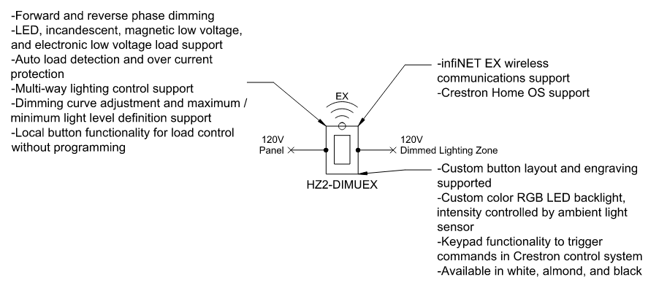

HZ2-DIMEX
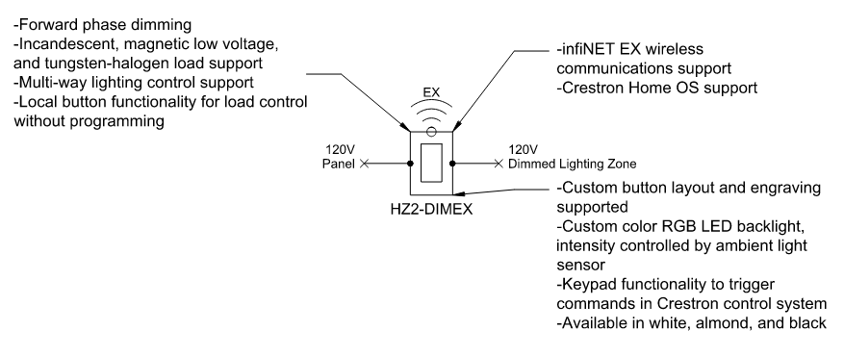

HZ2-DIMLVEX
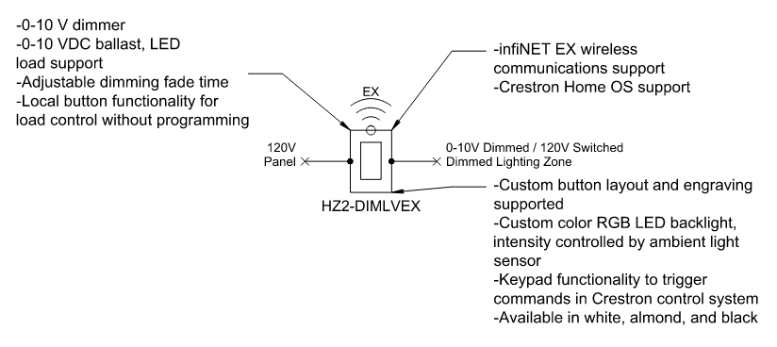

HZ2-SWEX
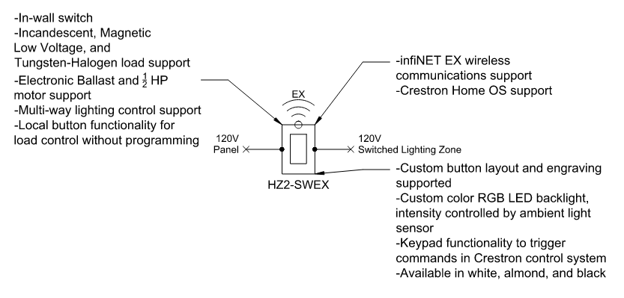

HZ2-KPEX
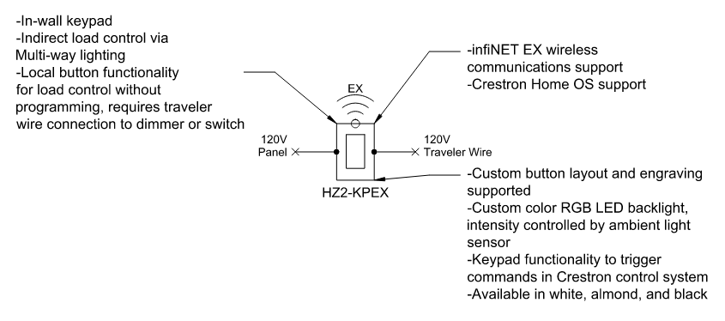

HZ2-AUX
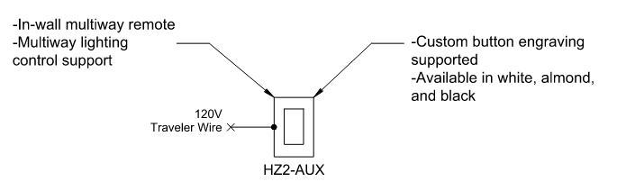

HZ2-KPCN
