SECTION 27 41 16
INTEGRATED AUDIO-VIDEO SYSTEMS AND EQUIPMENT

GUIDE SPECIFICATION

Specifier: The Specifier/Design Professional is responsible for the accuracy of all project specifications, including system application and coordination with related sections. This guide specification is provided as a convenience and requires editing to match actual project requirements. CRESTRON ELECTRONICS, INC. SHALL NOT BE LIABLE FOR ANY DAMAGES ARISING OUT OF THE USE OF ANY OF ITS GUIDE SPECIFICATIONS. For Crestron design assistance and design review please contact Sales Support Services Department at 800.237.2041 or techsales@crestron.com.

Specifier: Please see PART 4 for a listing of products specified in this Guide Specification.

Table of Contents
1 GENERAL 4
1.1 Description: Managed Audio Video Network Switches 4
2 PRODUCTS 4
2.1 Switch Type 1 4
2.1.1 Basis of Design 4
2.1.2 Device Architecture 4
2.1.3 Functions 5
2.1.4 Controls and Indicators 7
2.1.5 Connectors 7
2.1.6 Power Requirements 8
2.2 Switch Type 2 8
2.2.1 Basis of Design 8
2.2.2 Device Architecture 9
2.2.3 Functions 9
2.2.4 Controls and Indicators 11
2.2.5 Connectors 12
2.2.6 Power Requirements 13
2.3 Switch Type 3 13
2.3.1 Basis of Design 13
2.3.2 Device Architecture 13
2.3.3 Functions 14
2.3.4 Controls and Indicators 16
2.3.5 Connectors 17
2.3.6 Power Requirements 18
2.4 Switch Type 4 18
2.4.1 Basis of Design 18
2.4.2 Device Architecture 18
2.4.3 Functions 19
2.4.4 Controls and Indicators 21
2.4.5 Connectors 22
2.4.6 Power Requirements 22
3 EXECUTION 23
4 APPENDICES 23
4.1 SPECIFIED PRODUCTS 23
4.1.1 Crestron CEN-SWPOE-10 23
4.1.2 Crestron CEN-SWPOE-ULTRA-12 23
4.1.3 Crestron CEN-SWPOE-30 23
4.1.4 Crestron CEN-SWPOE-48 23
4.2 Input / Output Connection Diagrams 24
4.2.1 CEN-SWPOE-10 24
4.2.2 CEN-SWPOE-ULTRA-12 24
4.2.3 CEN-SWPOE-30 25
4.2.4 CEN-SWPOE-48 26

GENERAL
NOT USED in this Guide Specification. Specifier shall Specify PART 1 administrative and procedural requirements as needed.

Description: Managed Audio Video Network Switches

PRODUCTS

Switch Type 1

Specifier Note:
The CEN-SWPOE-10 is a 10 port managed Ethernet switch that provides PoE+ from eight of its ports. The two 10 Gigabit Base-X SFP+ ports enable use of transceiver modules to connect to a fiber network.

Basis of Design

Crestron CEN-SWPOE-10

Device Architecture

Physical Form factor

Construction

Chassis: Metal, black finish, fan-cooled, vented sides

Mounting: Freestanding, or mountable on a flat surface

Dimensions

Height: 1.57 in. (40 mm)

Width: 8.26 in. (210 mm)

Depth: 5.51 in. (140 mm)

Device weight: 2.13 lb. (9.67 kg)

Environmental Operating Conditions

32° to 122° F (0° to 50° C)

10% to 90% RH (non-condensing)

Ambient Noise: 3 dB at 77° F (25° C)

Functions

Ethernet

Ports

(8) 10/100/1000Base-T auto-sensing Gigabit Ethernet w/PoE+

(2) 10 Gigabit Base-X SFP+

Network Standards: IEEE 802.3af, 802.3at

MAC Addresses: Up to 16K

Switch Fabric: 56 Gbps non-blocking

Lite Layer 3 Package

Management

Out-of-band, IT Web GUI (main), HTTPs, CLI, Telnet, SSH, SNMP, MIBs, RSPAN, Radius users, TACACS+

IPv4/IPv6 ACL and QoS

Ingress/egress, 1 Kbps shaping, time-based, Single rate policing

IPv4/IPv6 Multicast Filtering

Automated IGMP between switches, IGMPv3 MLDv2 snooping, proxy ASM and SSM, IGMPv1, v2 querier (compatible with v3), Control packet flooding

IPv4/IPv6 Policing and Convergence

Auto-VoIP, Policy-based routing, LLDP-MED, IEEE 1588 PTPv2

IPv4/IPv6 Authentication Security

Successive tiering (DOT1X, MAB, Captive portal), DHCP snooping, Dynamic ARP inspection, IP source guard

IPv4/IPv6 Static Routing

Port, subnet, VLAN routing, Multicast static routes, DHCPv4 server, DHCP relay, Stateful DHCPv6 Server

IPv4/IPv6 Dynamic Routing

IPv4: RIP

IPv4/IPv6: PIM-SM, PIM-DM, SSM

Spanning Tree Green Ethernet

STP, MTP, RSTP, PV(R)STP, BPDU/STRG, EEE 802.3az

VLANs

Static, dynamic, voice, MAC, GVRP/GMRP, Double VLAN mode, Private VLANs

Controls and Indicators

Indicators

POWER: (1) green LED, indicates operating power supplied via main power input

FAN: (1) green LED, indicates fan is in operation

PoE MAX: (1) green LED, indicates the unit is supplying the maximum amount of PoE

OOB: (2) green LEDs for Ethernet port, indicates Ethernet link status for out-of-band (service) port

1-8: (2) LEDs per each (8) Ethernet port, left (green) LEDs indicate Ethernet link status for each corresponding port, right (blue) LEDs indicate PoE for each corresponding port

9-10: (1) green LED per SFP+ port, indicates active connection

Connectors

OOB: (1) 8-wire RJ45, female; 10/100/1000Base-T Ethernet port

CONSOLE: USB-C® port, female

USB Storage: USB Type B, female

54V - 4.7A: (1) power connector

1-8: (8) 8-wire RJ45, female

10/100/1000Base-T Ethernet ports and PoE Power Sourcing Equipment (PSE) outputs

Supports IEEE 802.3at Type 2 PoE+ power sourcing from any ports up to the maximum specified power capabilities

Maximum 30 Watts per port, 220 Watts total

9-10: (2) SFP+ ports, female; 10 Gigabit Base-X SFP+

Power Requirements

Main Power: 4.7 Amps @ 100-240 Volts AC, 50/60 Hz

Power Consumption

Max PoE: 257.7 W

No PoE: 18.14 W

Standby: 9.51 W

Switch Type 2

Specifier Note:
The CEN-SWPOE-ULTRA-12 is a 12 port managed Ethernet switch that provides PoE++ from eight of its ports. The two 10 Gigabit Base-X SFP+ ports enable use of transceiver modules to connect to a fiber network.

Basis of Design

Crestron CEN-SWPOE-ULTRA-12

Device Architecture

Physical Form factor

Construction

Chassis: Metal, black finish, fan-cooled, vented sides

Mounting: Freestanding or 1U 19-inch rack-mountable with reversible rack ears

Dimensions

Height: 1.7 in. (43.2 mm)

Width: 17.32 in. (440 mm)

Depth: 10.11 in. (257 mm)

Device weight: 8.44 lb. (3.83 kg)

Environmental Operating Conditions

32° to 122° F (0° to 50° C)

10% to 90% RH (non-condensing)

Ambient Noise: 50.5 dB at 77° F (25° C)

Functions

Ethernet

Ports

(2) 10/100/1000Base-T auto-sensing Gigabit ethernet

(8) 10/100/1000Base-T auto-sensing Gigabit Ethernet w/PoE++

(2) 10 Gigabit Base-X SFP+

Network Standards: IEEE 802.3af, 802.3at, 802.3bt

MAC Addresses: Up to 16K

Switch Fabric: 60 Gbps non-blocking

Lite Layer 3 Package

Management

Out-of-band, IT Web GUI (main), HTTPs, CLI, Telnet, SSH, SNMP, MIBs, RSPAN, Radius users, TACACS+

IPv4/IPv6 ACL and QoS

Ingress/egress, 1 Kbps shaping, time-based, Single rate policing

IPv4/IPv6 Multicast Filtering

Automated IGMP between switches, IGMPv3 MLDv2 snooping, proxy ASM and SSM, IGMPv1, v2 querier (compatible with v3), Control packet flooding

IPv4/IPv6 Policing and Convergence

Auto-VoIP, Policy-based routing, LLDP-MED, IEEE 1588 PTPv2

IPv4/IPv6 Authentication Security

Successive tiering (DOT1X, MAB, Captive portal), DHCP snooping, Dynamic ARP inspection, IP source guard

IPv4/IPv6 Static Routing

Port, subnet, VLAN routing, Multicast static routes, DHCPv4 server, DHCP relay, Stateful DHCPv6 Server

IPv4/IPv6 Dynamic Routing

IPv4: RIP

IPv4/IPv6: PIM-SM, PIM-DM, SSM

Spanning Tree Green Ethernet

STP, MTP, RSTP, PV(R)STP, BPDU/STRG, EEE 802.3az

VLANs

Static, dynamic, voice, MAC, GVRP/GMRP, Double VLAN mode, Private VLANs

Controls and Indicators

Indicators

POWER: (1) green LED, indicates operating power supplied via main power input

FAN: (1) green LED, indicates fan is in operation

PoE MAX: (1) green LED, indicates the unit is supplying the maximum amount of PoE

OOB: (2) green LEDs for Ethernet port, indicates Ethernet link status for out-of-band (service) port

1-8: (2) LEDs per each (8) Ethernet port, left (green) LEDs indicate Ethernet link status for each corresponding port, right (blue) LEDs indicate PoE for each corresponding port

9-10: (1) green LED per each (2) Ethernet port, indicates Ethernet link status for each corresponding port.

11-12: (1) green LED per SFP+ port, indicates active connection

Connectors

OOB: (1) 8-wire RJ45, female; 10/100/1000Base-T Ethernet port

CONSOLE: USB-C® port, female

USB-C: USB-C® port, female

100-240V: (1) power connector

USB: USB Type B, female

LED EXT: USB-C® port, female

1-8: (8) 8-wire RJ45, female

10/100/1000Base-T Ethernet ports and PoE Power Sourcing Equipment (PSE) outputs

Supports IEEE 802.3bt Type 3 PoE++ power sourcing from any ports up to the maximum specified power capabilities

Maximum 90 Watts per port, 720 Watts total

9-10: (2) 8-wire RJ45, female; 10/100/1000Base-T Ethernet Ports

11-12: (2) SFP+ ports, female; 10 Gigabit Base-X SFP+

Power Requirements

Main Power: 10 Amps @ 100-240 Volts AC, 50/60 Hz

Power Consumption

Max PoE: 837.7 W

No PoE: 26.3 W

Standby: 18 W

Switch Type 3

Specifier Note:
The CEN-SWPOE-30 is a 30 port managed Ethernet switch that provides PoE+ from 24 of its ports. The four 10 Gigabit Base-X SFP+ ports enable use of transceiver modules to connect to a fiber network.

Basis of Design

Crestron CEN-SWPOE-30

Device Architecture

Physical Form factor

Construction

Chassis: Metal, black finish, fan-cooled, vented sides

Mounting: Freestanding or 1U 19-inch rack-mountable with reversible rack ears

Dimensions

Height: 1.7 in. (43.2 mm)

Width: 17.32 in. (440 mm)

Depth: 15.74 in. (400 mm)

Device weight: 12.02 lb. (5.45 kg)

Environmental Operating Conditions

32° to 122° F (0° to 50° C)

10% to 90% RH (non-condensing)

Ambient Noise: 42 dB at 77° F (25° C)

Functions

Ethernet

Ports

(2) 10/100/1000Base-T auto-sensing Gigabit ethernet

(24) 10/100/1000Base-T auto-sensing Gigabit Ethernet w/PoE+

(4) 10 Gigabit Base-X SFP+

Network Standards: IEEE 802.3af, 802.3at

MAC Addresses: Up to 16K

Switch Fabric: 132 Gbps non-blocking

Lite Layer 3 Package

Management

Out-of-band, IT Web GUI (main), HTTPs, CLI, Telnet, SSH, SNMP, MIBs, RSPAN, Radius users, TACACS+

IPv4/IPv6 ACL and QoS

Ingress/egress, 1 Kbps shaping, time-based, Single rate policing

IPv4/IPv6 Multicast Filtering

Automated IGMP between switches, IGMPv3 MLDv2 snooping, proxy ASM and SSM, IGMPv1, v2 querier (compatible with v3), Control packet flooding

IPv4/IPv6 Policing and Convergence

Auto-VoIP, Policy-based routing, LLDP-MED, IEEE 1588 PTPv2

IPv4/IPv6 Authentication Security

Successive tiering (DOT1X, MAB, Captive portal), DHCP snooping, Dynamic ARP inspection, IP source guard

IPv4/IPv6 Static Routing

Port, subnet, VLAN routing, Multicast static routes, DHCPv4 server, DHCP relay, Stateful DHCPv6 Server

IPv4/IPv6 Dynamic Routing

IPv4: RIP

IPv4/IPv6: PIM-SM, PIM-DM, SSM

Spanning Tree Green Ethernet

STP, MTP, RSTP, PV(R)STP, BPDU/STRG, EEE 802.3az

VLANs

Static, dynamic, voice, MAC, GVRP/GMRP, Double VLAN mode, Private VLANs

Controls and Indicators

Indicators

POWER: (1) green LED, indicates operating power supplied via main power input

FAN: (1) green LED, indicates fan is in operation

PoE MAX: (1) green LED, indicates the unit is supplying the maximum amount of PoE

OOB: (2) green LEDs for Ethernet port, indicates Ethernet link status for out-of-band (service) port

1-24: (2) LEDs per each (24) Ethernet port, left (green) LEDs indicate Ethernet link status for each corresponding port, right (blue) LEDs indicate PoE for each corresponding port

25-26: (1) green LED per each (2) Ethernet port, indicates Ethernet link status for each corresponding port.

27-30: (1) green LED per SFP+ port, indicates active connection

Connectors

OOB: (1) 8-wire RJ45, female; 10/100/1000Base-T Ethernet port

CONSOLE: USB-C® port, female

100-240V: (1) power connector

USB: USB Type B, female

LED EXT: USB-C® port, female

1-24: (24) 8-wire RJ45, female

10/100/1000Base-T Ethernet ports and PoE Power Sourcing Equipment (PSE) outputs

Supports IEEE 802.3at Type 2 PoE+ power sourcing from any ports up to the maximum specified power capabilities

Maximum 30 Watts per port, 480 Watts total

25-26: (2) 8-wire RJ45, female; 10/100/1000Base-T Ethernet Ports

27-30: (4) SFP+ ports, female; 10 Gigabit Base-X SFP+

Power Requirements

Main Power: 6.4-2.5 Amps @ 100-240 Volts AC, 50/60 Hz

Power Consumption

Max PoE: 614 W

No PoE: 46.8 W

Standby: 33.90 W

Switch Type 4

Specifier Note:
The CEN-SWPOE-48 is a 48 port managed Ethernet switch that provides PoE+ from 40 of its ports. The eight 10 Gigabit Base-X SFP+ ports enable use of transceiver modules to connect to a fiber network.

Basis of Design

Crestron CEN-SWPOE-48

Device Architecture

Physical Form factor

Construction

Chassis: Metal, black finish, fan-cooled, vented sides

Mounting: Freestanding or 1U 19-inch rack-mountable with reversible rack ears

Dimensions

Height: 1.7 in. (43.2 mm)

Width: 17.32 in. (440 mm)

Depth: 15.74 in. (400 mm)

Device weight: 13.91 lb. (6.31 kg)

Environmental Operating Conditions

32° to 122° F (0° to 50° C)

10% to 90% RH (non-condensing)

Ambient Noise: 59 dB at 77° F (25° C)

Functions

Ethernet

Ports

(40) 10/100/1000Base-T auto-sensing Gigabit Ethernet w/PoE+

(8) 10 Gigabit Base-X SFP+

Network Standards: IEEE 802.3af, 802.3at

MAC Addresses: Up to 16K

Switch Fabric: 240 Gbps non-blocking

Lite Layer 3 Package

Management

Out-of-band, IT Web GUI (main), HTTPs, CLI, Telnet, SSH, SNMP, MIBs, RSPAN, Radius users, TACACS+

IPv4/IPv6 ACL and QoS

Ingress/egress, 1 Kbps shaping, time-based, Single rate policing

IPv4/IPv6 Multicast Filtering

Automated IGMP between switches, IGMPv3 MLDv2 snooping, proxy ASM and SSM, IGMPv1, v2 querier (compatible with v3), Control packet flooding

IPv4/IPv6 Policing and Convergence

Auto-VoIP, Policy-based routing, LLDP-MED, IEEE 1588 PTPv2

IPv4/IPv6 Authentication Security

Successive tiering (DOT1X, MAB, Captive portal), DHCP snooping, Dynamic ARP inspection, IP source guard

IPv4/IPv6 Static Routing

Port, subnet, VLAN routing, Multicast static routes, DHCPv4 server, DHCP relay, Stateful DHCPv6 Server

IPv4/IPv6 Dynamic Routing

IPv4: RIP

IPv4/IPv6: PIM-SM, PIM-DM, SSM

Spanning Tree Green Ethernet

STP, MTP, RSTP, PV(R)STP, BPDU/STRG, EEE 802.3az

VLANs

Static, dynamic, voice, MAC, GVRP/GMRP, Double VLAN mode, Private VLANs

Controls and Indicators

Indicators

POWER: (1) green LED, indicates operating power supplied via main power input

FAN: (1) green LED, indicates fan is in operation

PoE MAX: (1) green LED, indicates the unit is supplying the maximum amount of PoE

OOB: (2) green LEDs for Ethernet port, indicates Ethernet link status for out-of-band (service) port

1-40: (2) LEDs per each (40) Ethernet port, left (green) LEDs indicate Ethernet link status for each corresponding port, right (blue) LEDs indicate PoE for each corresponding port

41-48: (1) green LED per SFP+ port, indicates active connection

Connectors

OOB: (1) 8-wire RJ45, female; 10/100/1000Base-T Ethernet port

CONSOLE: USB-C® port, female

100-240V: (1) power connector

USB: USB Type B, female

LED EXT: USB-C® port, female

1-40: (40) 8-wire RJ45, female

10/100/1000Base-T Ethernet ports and PoE Power Sourcing Equipment (PSE) outputs

Supports IEEE 802.3at Type 2 PoE+ power sourcing from any ports up to the maximum specified power capabilities

Maximum 30 Watts per port, 960 Watts total

41-48: (8) SFP+ ports, female; 10 Gigabit Base-X SFP+

Power Requirements

Main Power: 12 Amps @ 100-240 Volts AC, 50/60 Hz

Power Consumption

Max PoE: 1197 W

No PoE: 89.2 W

Standby: 74.5 W

EXECUTION
NOT USED in this Guide Specification. Specifier shall Specify PART 3 On-Site work as needed.

APPENDICES

SPECIFIED PRODUCTS

Crestron CEN-SWPOE-10

Crestron CEN-SWPOE-ULTRA-12

Crestron CEN-SWPOE-30

Crestron CEN-SWPOE-48

Input / Output Connection Diagrams

CEN-SWPOE-10

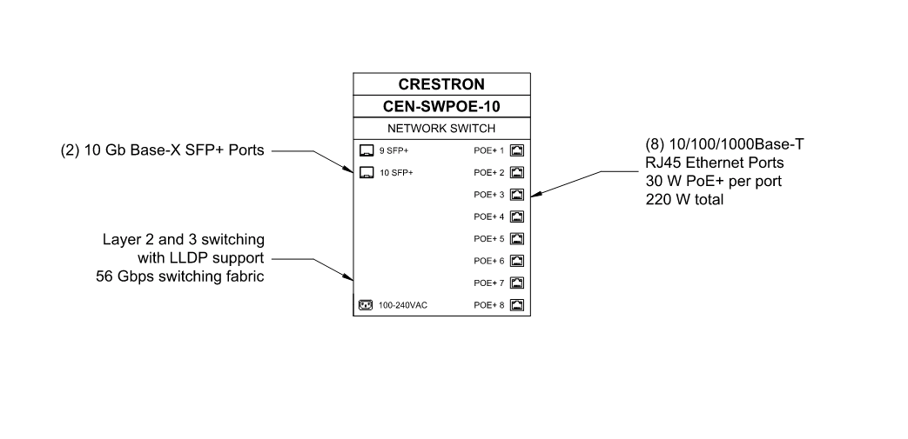

CEN-SWPOE-ULTRA-12

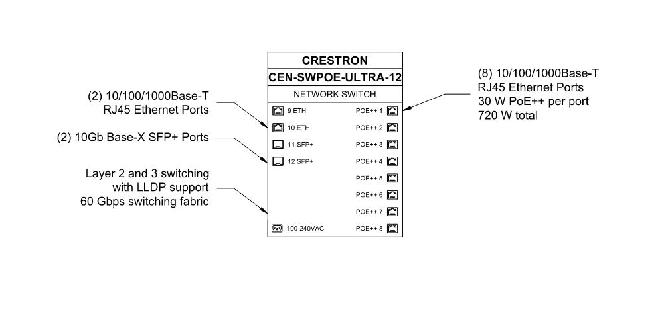

CEN-SWPOE-30

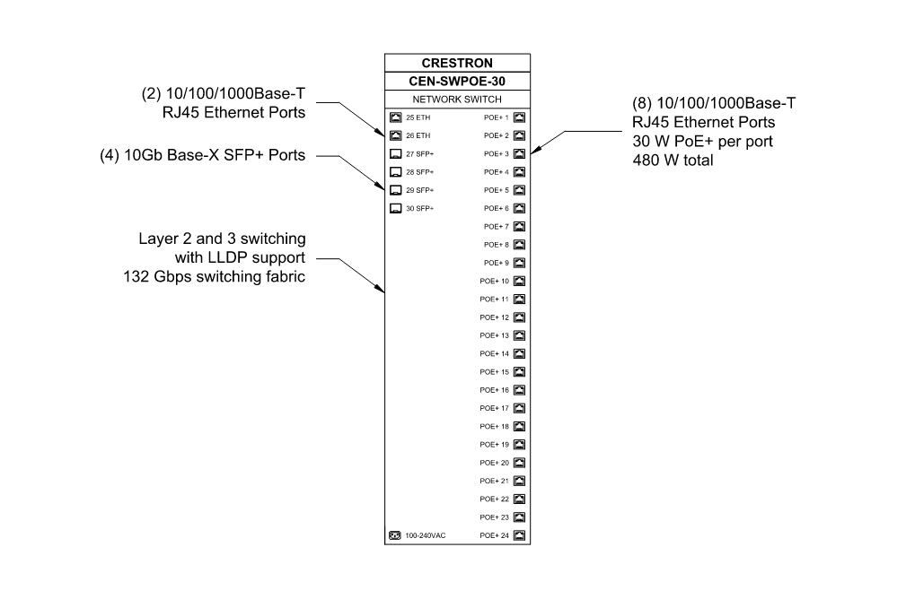

CEN-SWPOE-48

